Year 6 | Autumn |  | Spring |  | Summer
Core Texts | 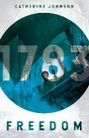  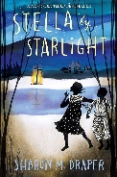 |  | 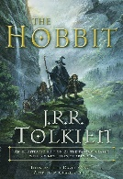  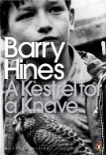 |  | 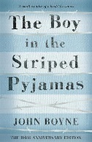
 | Freedom; Stella by Starlight |  | A Kestrel for a Knave; The Hobbit (Graphic Novel) |  | The Boy in the Striped Pyjamas;
Main Project | Maafa (History Driver) |  | Frozen Kingdoms (Geography Driver) |  | Britain At War (History Driver)
Writing | Instructions, Character Description, Short Narrative, Poetry |  | Description; Adventure Narrative; Non-Chronological Report, Persuasive Advert. |  | Historical Narrative; Diary Entry; Biography, Book Review
Maths | Calculating & Using Knowledge of Structures; Multiples of 1000 | Fractions & Percentages; Numbers to 10,000,000 | Draw, Compose & Decompose Shapes; Multiplication & Division | Fractions & Percentages; Area, Perimeter, Position & Direction | Statistics & Mean Average; Order of Operations; Ratio & Proportion | Ratio & Proportion; Solving Problems with 2 Unknowns; Calculating Using Knowledge & Structures; Life Skills
Science | Circulatory System  *Living things and their habitat are taught within Evolution and Frozen Kingdoms |  | Electrical Circuits and Components |  | Light Theory | Evolution and Inheritance  *Living things and their habitat are taught within Evolution and Frozen Kingdoms
History | Maafa |  | Revision & Recall |  | Britain At War
Geography | Our Changing World |  | Frozen Kingdoms |  | Revision & Recall
Art & Design | Tints, Tones & Shades; Trailblazers, Barrier Breakers |  | Inuit Art, Environmental Artists |  | Distortion & Abstraction; Bees, Beetles & Butterflies
DT | Food for Life |  | Engineer |  | Make Do & Mend
RE | Rosh Hashanah & Yom Kippur (Judaism) + Hannukah Mini Project |  | Lailat al Miraj (Islam) + Ramadan, Eid & Passover Mini Projects |  | Sunday (Christianity) | Kumbh Mela (Hinduism)
Music | Happy | Classroom Jazz 2 | A New Year Carol | You've Got a Friend | Music and Me | Reflect, Rewind and Replay
PE | Games: Handball  Games: Tag Rugby | Games: Hockey  OAA: Leadership | Gymnastics: Matching and Mirroring  Games: Netball | Games: Cricket  Dance: Titanic | Athletics: Running, Throwing and Jumping  Games: Tennis | Games: Rounders  Athletics: Athletics
Computing | Online Safety; Coding; Text adventures |  | Networks; Understanding Binary; Spreadsheets |  | Blogging; Excel Spreadsheets
PHSE | Topics covered progressively over the year: FBV, Water Safety, Alcohol, Stealing, Anger, Making Friends Online, In-App Purchases, Conception, First Aid (See PHSE Documents for Details)
MFL | School Life | School Life 2 | House & Home | Reading | Holidays | Holidays 2
Memorable Experiences | Tower Wood Lake District Residential; Introduction to Africa Video Call; Crucial Crew; Primary Enterprise Challenge |  | Birds of Prey Demonstration, Magna |  | Reward trip, Hepp DT day.

