Year 5 | Autumn |  | Spring |  | Summer
Core Texts | 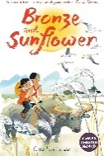 |  | 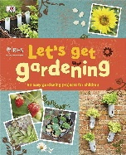  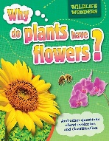  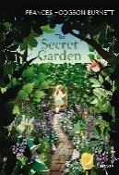 |  | 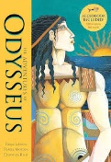  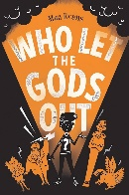
 | Bronze & Sunflower; Room 13 |  | The Secret Garden; Why Do Plants Have Flowers? & Let’s Get Gardening |  | Who Let The Gods Out?; The Adventures of Odysseus
Main Project | Dynamic Dynasties (History) |  | Sow, Grow & Farm (Geography) |  | Ground-breaking Greeks (History)
Writing | Narrative; Poem; Balanced Argument; Character & Setting Description; |  | Short Narrative; Non-Chronological Reports; Instructions; Explanation |  | Diary Entry; Persuasive letter; Non-Chronological Reports
Maths | Decimal Fractions; Money | Negative Numbers; Short Multiplication & Division | Area & Scaling | Calculating with Decimal Fractions; Factors, Multiples & Primes | Factors, Multiples & Primes; Fractions | Fractions; Converting Units; Angle & Transformations
Science | Forces and Mechanisms | Earth and Space | Human Reproduction and Ageing  *Living things and their habitat are taught within Human Reproduction and Sow, Grow and Farm |  | Properties and Changes of Materials
History | Dynamic Dynasties |  | Revision & Recall |  | Ground-breaking Greeks
Geography | Investigating Our World |  | Sow, Grow & Farm |  | Revision & Recall
Art & Design | Tints, Tones & Shades | Taotie | Line, Light & Shadow | Nature's Art | Mixed Media | Expression
DT | Moving Mechanisms |  | Eat The Seasons |  | Architecture
RE | Dharma Day (Buddhism) + Hannukah Mini Project |  | Holi (Hinduism) + Ramadan, Eid & Passover Mini Projects |  | Guru Arjan Gurpurab (Sikhism) | Pentecost (Christianity)
Music | Livin' On a Prayer | Classroom Jazz 1 | Make you Feel My Love | The Fresh Prince of  Bel-Air | Dancing In the Street | Reflect, Rewind and Replay
PE | Dance: Street Art  Games: Tag Rugby | Games: Handball  Games: Hockey | Gymnastics: Counter Balance & Counter Tension  Games: Cricket | Games: Netball  OAA: Orienteering | Dance: Greeks  Athletics: Running, Throwing and Jumping | Athletics: Athletics  Games: Rounders
Computing | Online Safety; Concept Maps; Word Processing |  | Game Creator; External Devices |  | Coding; 3D Modelling; Databases
PHSE | Topics covered progressively over the year: FBV, Peer Pressure, Smoking, Looking Out For Others, Worry, Image Sharing, Enterprise, Inclusion & Acceptance, Puberty, First Aid (See PHSE Documents for Details)
MFL | Shopping | High Street + Descrip. | Hobbies & Opinions | Food | Transactional Lang. | Weather
Memorable Experiences | National Space Centre; Hepp DT Day; Primary Enterprise Challenge; Bikeability; Shang Dynasty Workshop |  | Tesco Farm to Fork Tour; National Videogame Museum |  | Royal Armouries & Workshop

