Year 3 | Autumn |  | Spring |  | Summer
Core Texts | 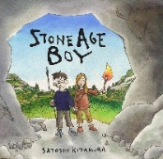  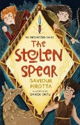  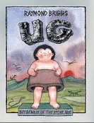 |  | 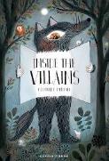  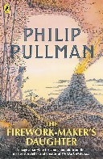  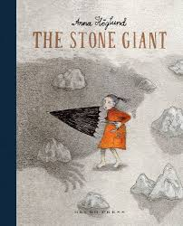 |  | 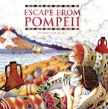  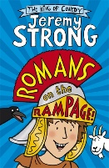  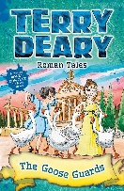
 | The Stolen Spear; Stone Age Boy; Ug |  | The Firework Maker's Daughter; The Stone Giant; |  | The Goose Guards; Romans on the Rampage; Escape From Pompeii
Main Project | Through the Ages (History) |  | Rocks, Relics & Rumbles (Geography) |  | Emperors & Empires (History)
Writing | Focus on Basic Skills & Structures; Instructions; Setting Descrip.; Character Description; Narrative |  | Information Text; Non-Chronological Report; Poetry; Narrative |  | Biographies; Letter Writing; Historical Report; Narrative
Maths | Adding & Subtracting Across 10; Numbers to 100 | Numbers to 1000; Right Angles | Manipulating the Additive Relationship and Securing Mental Calculation; Column Addition | Column Addition; Times Tables | Column Subtraction; Unit Fractions | Non-Unit Fractions; Parallel & Perpendicular Sides in Polygons; Time
Science | Animal Nutrition | The Skeletal System | Forces and Magnets  *Rocks are taught within Rocks, Relics and Rumbles |  | Plant Nutrition and Reproduction | Light and Shadows
History | Through the Ages |  | Revision & Recall |  | Emperors & Empires
Geography | Our Planet, One World |  | Rocks, Relics & Rumbles |  | Revision & Recall
Art & Design | Contrast & Compliment | Prehistoric Pots | Ammonite | People & Places | Beautiful Botanicals | Mosaic Masters
DT | Cook Well, Eat Well |  | Making It Move! |  | Greenhouse
RE | Ganesha Chaturthi (Hinduism) + Christmas Mini Project |  | Lent (Christianity) + Ramadan, Eid & Easter Mini Project |  | Hajj (Islam) | Shavout (Judaism)
Music | Let Your Spirit Fly | Glockenspiel Stage 1 | Three Little Birds | Dragon Song | Bringing Us Together | Reflect, Rewind and Replay
PE | Games: Basketball  Games: Dodgeball | Gymnastics: Symmetry/Asymmetry  Games: Football | Swimming  Gymnastics: Symmetry/Asymmetry | Swimming  Dance: Wild Animals | Swimming  OAA: Communication and tactics | Athletics: Athletics  Games: Rounders
Computing | Online Safety; Touch Typing; Presenting; Graphing |  | Branching Databases; Email & Safety |  | Coding; Simulations; Spreadsheets
PHSE | Topics covered progressively over the year: FBV, Staying Safe, Leaning Out of Windows, Medicine, Touch, Stealing, Grief, Making Friends Online, Looking After Our World, Fire Stations, Is It Safe to Play With? (See PHSE Documents for Details)
MFL | Numbers & High Freq | Greetings | Colours | Food | Reading | Days & Months
Memorable Experiences | Murton Hall Visitor; Primary Enterprise Challenge |  | Poole's Cavern; Hepp DT Day; Fire Service Visit |  | Castleton Residential (Peak District); Roman Shield Workshop; Romans VR Day

