Year 2 | Autumn |  | Spring |  | Summer
Core Texts | 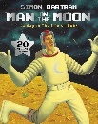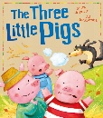 |  | 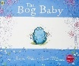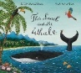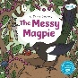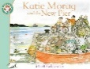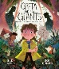 |  | 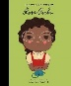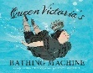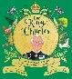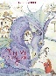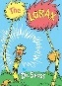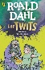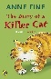
 | The Man on the Moon, The Three Little Pigs |  | The Snail and the Whale, Bog Baby, Greta and the Giants, Messy Magpie, Katie Morag and the New Pier |  | Queen Victoria’s Bathing Machine, Little People, Big Dreams: Rosa Parks, The Diary of a Killer Cat, The Twits, Our King Charles: His Remarkable Journey from Prince to King, Tell Me a Dragon, The Lorax
Main Project | Movers & Shakers (History) |  | Coastlines (Geography) |  | Magnificent Monarchs (History)
Writing | Clear focus on basic skills and structures, Captions, Letter formation, Retell known narrative, Recount historical event, Recount event |  | Character description, Retell a narrative, Information text, Poetry, Setting description, Recount event |  | Instruction, Information text, Character description, Narrative retell & reimagining, Recount event
Maths | Numbers 10 to 100; Calculations within 20 | Add & Subtract Within 10; Addition & Subtraction of 2 Digit Numbers; Intro to Multiplication | Intro to Multiplication; Intro to Division Structures | Shape; Add & Subtract 2 Digit Numbers | Money; Fractions; Time; Position & Direction | Multiplication and Division – Doubling, Halving, Quotitive and Partitive Division; Sense of Measure: Capacity, Volume & Mass
Science | Human Survival | Habitats | Uses of Materials | Plant Survival | Animal Survival
History | Movers & Shakers |  | Revision & Recall |  | Magnificent Monarchs
Geography | Let’s Explore the World |  | Coastlines |  | Revision & Recall
Art & Design | Mix It, Still Life |  | Flower Heads |  | Portraits & Poses
DT | Remarkable Recipes |  | Beach Hut |  | Cut, Stitch & Join | Push & Pull
RE | Navratri (Hinduism), Christmas (Christianity) |  | Losar (Buddhism), Ramadan & Eid al-Fitr (Islam), Easter (Christianity) |  | Jumu’ah (Islam), Anand Karaj (Sikhism)
Music | Hands, Feet and Heart | Ho, Ho, Ho | I Wanna Play in a Band | Zootime | Friendship Song | Reflect, Rewind and Replay
PE | Locomotion: Jumping 1  Ball skills: Hands 1 | Dance: Explorers  Locomotion: Feet 1 | Gymnastics: Linking  Ball Skills: Hands 2 | Dance: Water  Locomotion: Dodging | Team Building  Ball Skills: Rackets, Balls, Bats | Games for understanding  Gymnastics: Pathways
Computing | Online Safety, Presenting Ideas, Questioning |  | Effective Searching; Making Music, Spreadsheets |  | Coding, Creating Pictures
PHSE | Topics covered progressively over the year: FBV, Tying Shoelaces, Healthy Eating, Brushing Teeth, Bullying, Body Language, Practice Makes Perfect, Helping Someone in Need, Worry, Anger, Image Sharing, Computer Safety, Living & Working in Our World, Petty Arson, Testing When Driving, Is IT Safe To Play With? (See PHSE Documents for Details)
MLF | N/A |  | N/A |  | Introduction to French
Memorable Experiences | Lotherton Hall, Primary Enterprise Challenge |  | Withernsea Lighthouse, Cudworth Fieldwork, HEPP DT |  | Leeds Tropical World, Butterflies

