Year 1 | Autumn |  | Spring |  | Summer
Core Texts | 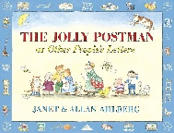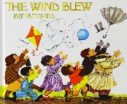 |  | 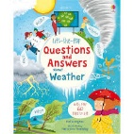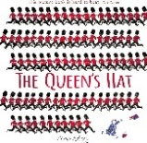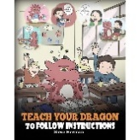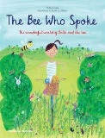 |  | 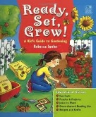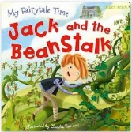
 | Wilfred Gordon McDonald Partridge; Old Bear; The Jolly Postman; The Wind Blew |  | The Queen's Hat; Teach Your Dragon To Follow Instructions; Q & A About Weather; The Bee Who Spoke |  | Dear Greenpeace; Ready, Set, Grow; Jack and the Beanstalk
Main Project | Childhood (History) |  | Bright Lights, Big City (Geography) |  | School Days (History)
Writing | Letter Formation; Caption Writing; CV/CVC Words |  | Sentence Writing; Setting Description; Instructions; Recount; Simple narrative |  | Sentence Writing; Recount; Information Writing; Poetry; simple narrative
Maths | Counting Within 100 | Comparison of Quantities & Part-Whole Relationship; Numbers 0 to 5 | Recognise, Compose, Decompose & Manipulate 2D & 3D Shapes; Numbers 0 to 10; Additive Structures | Additive Structures; Add & Subtract Within 10 | Numbers 0 to 20; Unitising & Coin Recognition | Unitising & Coin Recognition; Position & Direction; Time
Science | Everyday Materials | Human Senses | Seasonal Changes |  | Plant Parts | Animal Parts
History | Childhood |  | Revision & Recall |  | School Days
Geography | Our Wonderful World |  | Bright Lights, Big City |  | Revision & Recall
Art & Design | Mix It; Funny Faces & Fabulous Features |  | Rain & Sunrays |  | Street View
DT | Shade & Shelter |  | Taxi! |  | Chop, Slice & Mash
RE | Harvest (Christianity) + Xmas Mini-Project |  | Purim (Judaism) + Ramadan, Eid & Easter Mini Projects |  | Naam Karan (Sikhism) |  | Esala Perahera (Buddhism)
Music | Hey You! | Rhythm in the Way We Walk & Banana Rap | In The Groove | Round & Round | Your Imagination | Reflect, Rewind & Replay
PE | Locomotion: Running 1  Ball skills: Hands 1 | Ball Skills: Feet 1  Dance: Growing | Gymnastics: Body Parts  Locomotion: Jumping 1 | Dance: Heroes  Ball Skills: Hands 2 | Gymnastics: Wide, Narrow, Curled  Ball Skills: Rackets, Balls, Bats | Team Building  Dance: The Zoo
Computing | Online Safey; Grouping & Sorting; Pictograms; Lego Builders |  | Maze Explorers; Technology Outside School; Animated Story Books |  | Coding; Spreadsheets
PHSE | Topics covered progressively over the year: FBV, Road Safety, Washing Hands, Friendship, Water Spillage, Jealousy, Online Bullying, Growing Up in Our World, Hoax Calling, Is It Safe to Eat or Drink? (See PHSE Documents for Details)
Memorable Experiences | Forest Schools; Den Building |  | Village Tour; Sheffield City Centre Visit |  | Hepp DT Day; Armley Mill; Victorian School

