FS2 | Autumn 1 | Autumn 2 | Spring 1 | Spring 2 | Summer 1 | Summer 2
Core Texts | 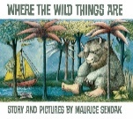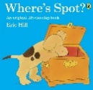  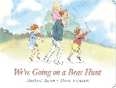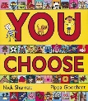  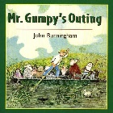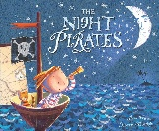  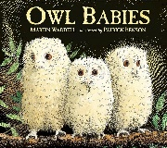 | 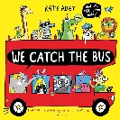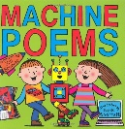  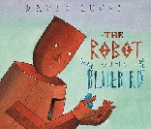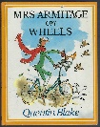  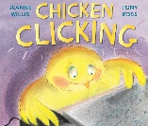 | 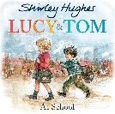  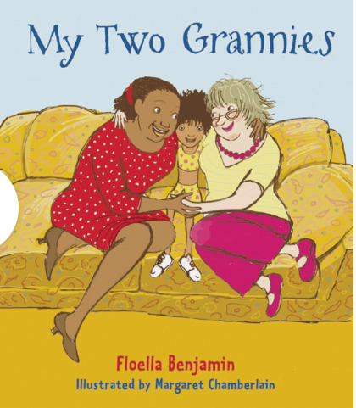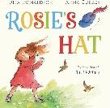  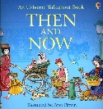  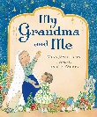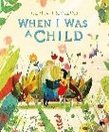 | 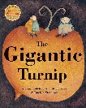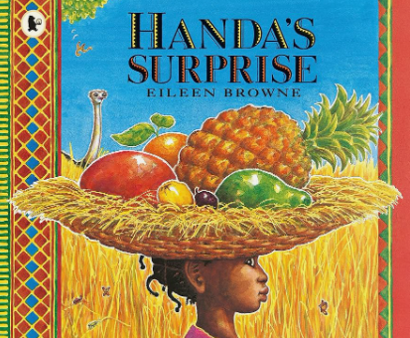  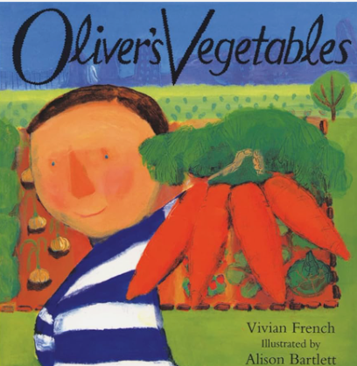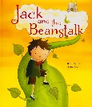  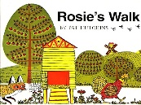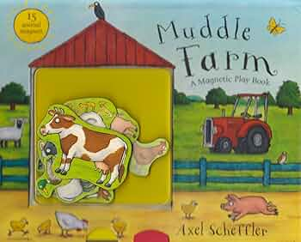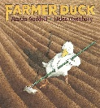 | 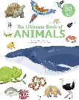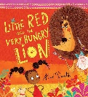  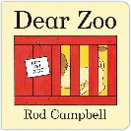  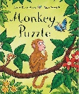 | 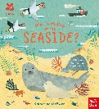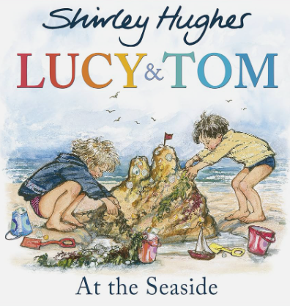  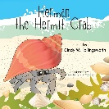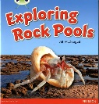  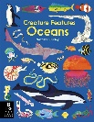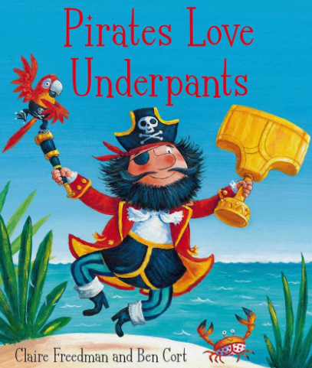
 | Where the Wild Things Are  Where’s Spot?  We’re Going on a Bear Hunt  You Choose  Mr Gumpy’s Outing  The Night Pirate  Owl Babies | We Catch the Bus Car, Car, Truck, Jeep  Machine Poems  The Robot and the Bluebird  Mrs Armitage on Wheels Chicken Clicking | Lucy & Tom  The Tiger who Came to Tea  My Two Grannies  Rosie’s Hat  The History of Toys  Then and Now  My Grandma and Me  When I Was a Child | The Gigantic Turnip Handa’s Surprise  Oliver’s Vegetables  Jack & The Beanstalk Rosie’s Walk  Muddle Farm  Farmer Duck | Book of Animals  Little Red & The Very Hungry Lion  Dear Zoo  From Head to Toe Monkey Puzzle | Who’s Hiding at the Seaside?  Lucy and Tom at the Seaside  Herman the Hermit Crab  Exploring Rock Pools Creatures from Oceans Pirates Love Underpants
Rhymes & Poems | 5 Currant Buns in a Baker Shop  5 Little Speckled Frogs  Wheels on the Bus  Head Shoulders Knees and Toes | 1,2,3,4,5 Once I Caught a Fish Alive  5 Little Men in a Flying Saucer  Ruldolph the Red Nose Reindeer | There Was a Princess Long Ago  Jack and Jill Went Up The Hill  Little Miss Muffet  Sing a Song of Sixpence  The Grand old Duke of York | 10 in a Bed  Mary, Mary Quiet Contrary  Mary Had a Little Lamb Tiny Little Caterpillar Curled Up on a Leaf  Old Macdonald Had a Farm | The Animals Went in 2 by 2  Down in the Jungle Humpty Dumpty  Ring a Ring a Roses | The Sun Has Got His Hat On  One, Two Buckle my Shoe  Tommy Thumb

FS2 | Autumn 1 | Autumn 2 | Spring 1 | Spring 2 | Summer 1 | Summer 2
Main Project | Let's Explore! | Marvellous Machines | Long Ago | Ready, Steady Grow | Animal Safari | On The Beach
Mini Project | Build it Up! | Puppets & Pop-Ups! | Stories & Rhymes | Signs of Spring | Creep, Crawl, Wiggle | Movie On; Move It!
RE | My World - Me, My Family & Other People |  | Special Times |  | Special Places
Music | Me | My Stories | Everyone | Our World | Big Bear Funk | Reflect, Rewind & Replay
PE | Gymnastics: Moving  *Physical Development- Gross motor skills  Covered in continuous provision | Dance: Nursery Rhymes  *ELG: Being Imaginative and Expressive  Covered in continuous provision | Locomotion: Walking  Gymnastics: High, Low, Over and Under | Dance: Ourselves  Ball Skills: Hands 1 | Dance: Dinosaurs  Balls Skills: Hands 2 | Ball skills: Feet 1  Games for understanding
Computing | EYFS objectives to be covered through use of Mini Mash and provision to prepare them for Computing in KS1:  To sequence events  To gain knowledge of how to use electronic devices  To choose suitable programs to complete tasks (selecting programs within the Mini Mash app).
PHSE | 1Decision PSED Progression Mapping
Memorable Experiences | Cudworth Park; Little City | Puppeteer's Workshop | St John’s Church | Cannon Hall Farm | ZooLab Mini-Beats; Duckling Hatching | Athlete Visit; Seaside Visit

