Last Updated | 01/09/2022

September 2022 – September 2025
Active Travel Policy

Contents
1. Our School 3
1.1 Our Vision 3
1.2 Our Values 3
1.3 Our Golden Rule 3
1.4 Our School Aims 4
1.5 Our Community 4
1.6 Our Academy Trust 4
2. Policy Summary 5
2.1 Policy Introduction & Rationale 5
2.2 Policy Aims 5
2.3 Inclusivity Statement 5
3. Legalities & Linked Documents 5
3.1 Linked School & Trust Policies 5
3.2 Linked National & Local Documents 5
4. Benefits of Active Travel 5
5. Strategies for Active Travel 6
6. Key Responsibilities 6
6.1 Pupils 6
6.2 Parents/ Carers 6
7. Additional Information 6

1. Our School

1.1 Our Vision
Grow. Achieve. Shine - These are much more than words or a motto. At Churchfield Primary School we enable all children to grow as independent learners, achieve more than they ever believe they could and shine as unique individuals. Our school is a very special place, having been the beating heart of our community for over 120 years, we respect the lessons of the past whilst looking to the difference we can make in the future. Preparing our pupils for life in an ever-changing world, developing curious, well-rounded individuals who are determined to succeed.

1.2 Our Values
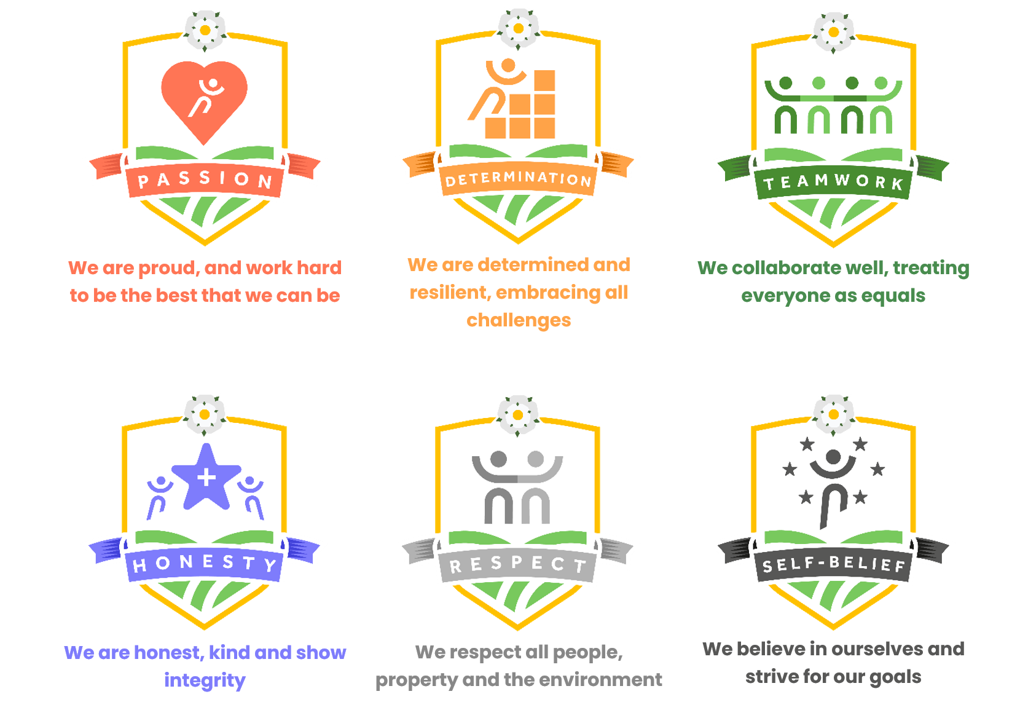

1.3 Our Golden Rule
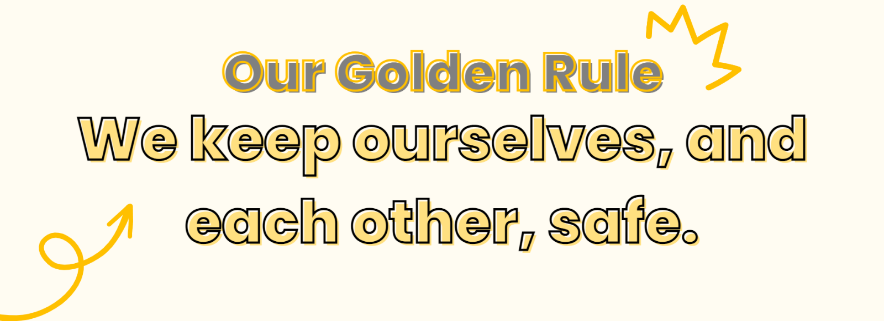

1.4 Our School Aims

Our school aims are underpinned by our values. Through our school values, we aim to:
- Promote high standards of academic and vocational achievement for every child, every time, through a highly-inclusive approach.
- Promote a holistic view of the whole child, supporting them to become well-rounded individuals and members of society.
- Encourage all children to develop positive relationships with, and respect for, themselves, each other, our local community and the wider world.
- Provide a safe, welcoming and positive environment for our children and families; acting as a hub at the heart of our community.

1.5 Our Community
Bricks and mortar do not make a school, people do. We can achieve great things when we work together, and our community is at the heart of what we do. We are a hub of support for our families, and provide a safe and loving environment for our children to shine.

1.6 Our Academy Trust
Since December 2019 we have been a proud member of Waterton Academy Trust, providing even more opportunities for our pupils to shine. As part of the Waterton family, we ensure that success for all is not a goal, but an expectation.

2. Policy Summary

2.1 Policy Introduction & Rationale
At Churchfield Primary School we are committed to increasing the levels of active and sustainable travel on the school journey. We encourage pupils, parents and staff to travel to school by cycling, scooting and walking wherever possible. We will work in partnership with the local authority and other organisations to help us. This school travel policy explains how we will be encouraging active travel to school. We will discuss the policy with the pupils, parents and governors and re-visit it periodically to ensure its relevance. For pupils, parents or staff unable to travel to school actively, we encourage use of public transport, park and stride or car-share.

2.2 Policy Aims
This policy is underpinned by the central aims of Churchfield Primary School and the values held by the school community. This policy aims to:

- Provide information for all stakeholders on the benefits of active travel
- Provide information for all stakeholders on what we do as a school to p

2.3 Inclusivity Statement
At Churchfield Primary School we use an inclusive approach to all aspects of education. Our aim is to always involve all children and stakeholders in all areas of the curriculum and school life. In accordance with the SEND Code of Practice, we recognise that this may mean making special adaptations or arrangements from time to time for children with specific disabilities. We welcome the involvement of disabled adults in all areas of school life.

3. Legalities & Linked Documents

3.1 Linked School & Trust Policies
This policy should be read in conjunction with the following policies and other linked policies:

- Safeguarding Policy
- Health & Safety Policy
- Walking Home Policy

3.2 Linked National & Local Documents
The policy has been developed in accordance with the following legislation and guidance:

- Working together to Safeguard Children
- Keeping Children Safe in Education

4. Benefits of Active Travel

Some of the benefits of active travel are:

- Establishing positive active travel behaviour
- Improving both mental and physical health through physical activity
- Promoting independence and improving safety/spatial awareness
- Reducing congestion, noise and pollution in the community
- Reducing the environmental impact of the journey to school

5. Strategies for Active Travel

To encourage pupils to walk, cycle or scoot to school frequently the school will:

- Actively promote cycling, scooting and walking as a positive way of travelling
- Celebrate the achievements of those who cycle, scoot and walk to school
- Provide cycle and scooter storage on the school site
- Provide high quality cycle/scooter training to all pupils who wish to participate
- Provide educational sessions to increase awareness around road safety

6. Key Responsibilities

6.1 Pupils
To make cycling and scooting to and from school a positive experience for everybody concerned, we expect our pupils to:

- Ride sensibly and safely and to follow the Highway Code
- Check that their bicycle or scooter is roadworthy and regularly maintained
- Behave in a manner which shows them and the school in the best possible light and to consider the needs of others when cycling or scooting
- Wear a cycle helmet whilst riding their bike and/ or scooter.
- Ensure they can be seen by other road users, by using lights and wearing high-visibility clothing, as appropriate

6.2 Parents/ Carers
For the wellbeing of our pupils, we expect parents and carers to:

- Encourage their child to walk, cycle or scoot to school whenever possible
- Encourage their child to take up opportunities to develop their competence and confidence in cycling or scooting
- Consider cycling or scooting with their child on the school run, possibly joining with other families as a ‘cycle train’
- Provide their child with equipment such as high-visibility clothing, lights, a lock and cycle helmet as appropriate
- Ensure that the bicycles and scooters ridden to school are roadworthy and regularly maintained.

7. Additional Information

Please note:

- The decision as to whether a child is competent to cycle, scoot or walk safely to and from school rests with the parent(s)/carer(s). The school has no liability for any consequences of that decision
- This policy covers the journey to and from school where the school has no responsibility or liability. When walking, scooting and cycling activities are being led by the school there may additional rules and guidance concerning equipment such as use of helmets, high visibility clothing, etc
- Parents are advised to consider appropriate insurance cover (check home insurance) as the school is not liable for, and its insurance does not cover, any loss or damage to bicycles and scooters being used on the way to or from school.

