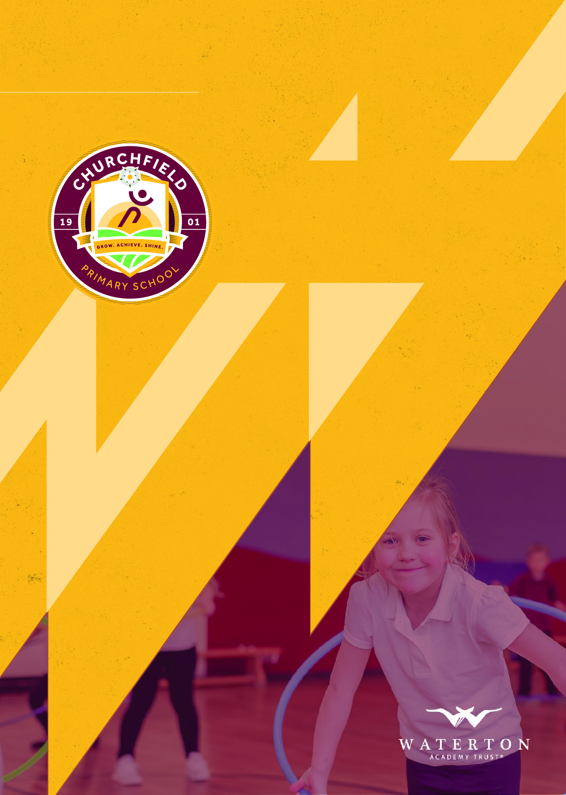
01/02/2022 | J Bean

September 2021 - September 2022
Rewards & Behaviour Policy

Contents
1. Our School 4
1.2 Our Vision 4
1.2 Our Values 5
1.3 Our Golden Rule 5
2. Policy Summary 5
2.1 Policy Introduction 5
2.2 Policy Aims 6
2.3 Policy Rationale 6
2.4 Inclusivity Statement 6
3. Legalities & Linked Documents 6
4.1 Linked School & Trust Policies 6
4.2 Linked National & Local Documents 7
5. Principles of Behaviour 7
5.1 Our Ethos 7
5.2 School Values 7
5.3 The Golden Rule 8
7. Definitions 8
7.1 Misbehaviour 8
7.2 Serious Misbehaviour 8
7.3 Bullying 8
8. Our Approach to Behaviour 8
8.1 Rewarding Consistently Good Behaviour 9
8.2 Rewarding Good Attendance 9
8.3 Lunchtimes 9
9. Awards & Prizes 10
9.1 Golden Awards & Behaviour All-Stars 10
9.2 House Points 10
9.3 Star of the Day 10
9.4 Value Awards 10
9.5 Churchfield Champion Postcards 11
9.6 Good To Be Green 11
10. Good To Be Green System 11
10.1 Good to be Green 11
10.2 Amber (Warning) 12
10.3 Red (Consequences) 12
11. Incident Reporting & Communication 12
11.1 Reporting ‘Red’ Incidents 12
11.2 SEND Incident Reporting 13
11.3 Safeguarding 13
11.3 Communication with Families 13
11.4 Link Between Home & School 14
12. Specific Negative Behaviours 14
12.1 Unacceptable/ Inappropriate Behaviour 14
12.2 Prejudice Behaviour 14
12.3 Physical & Verbal Abuse 15
12.4 Sexual Harassment & Sexual Violence 15
13. After-Incident Support 15
13.1 Learning Mentor Support 15
13. 2 Monitoring & Improving Persistently Negative Behaviour 15
14. Off-Site Behaviour 16
15. Additional Info 16
15.1 Accidents 16
15.2 Physical Intervention 17
15.3 Use of CCTV 17
15.4 Malicious Allegations Against Staff 17
15.5 Malicious Sexual Allegations 17
16. Confiscation & Search 17
17. Bullying 17
18. Responsibilities 18
18.1 Staff Training 18
18.2 Headteacher Responsibilities 18
18.3 Staff Responsibilities 18
18.4 Parents 19
18.5 Academy Standards Committee 19
Appendix A – Behaviour & Rewards Poster 19

1. Our School

1.2 Our Vision
Grow. Achieve. Shine - These are much more than words or a motto. At Churchfield Primary School we enable all children to grow as independent learners, achieve more than they ever believe they could and shine as unique individuals. Our school is a very special place, having been the beating heart of our community for over 120 years, we respect the lessons of the past whilst looking to the difference we can make in the future. Preparing our pupils for life in an ever-changing world, developing curious, well-rounded individuals who are determined to succeed.

1.2 Our Values
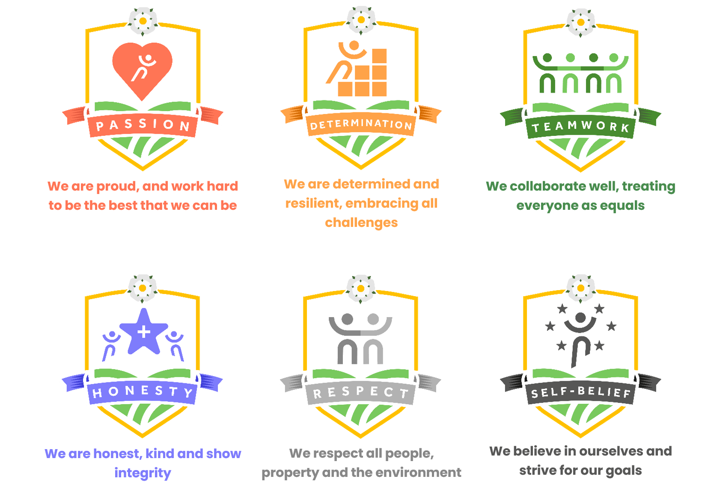

1.3 Our Golden Rule
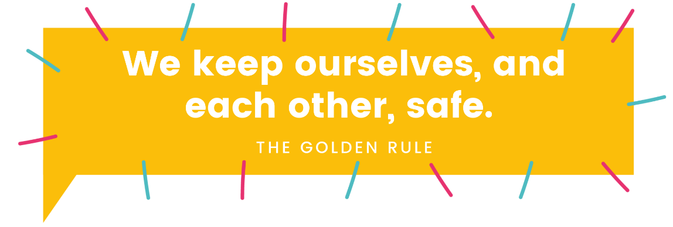

2. Policy Summary

2.1 Policy Introduction
Good behaviour is paramount to effective learning, and at Churchfield Primary School, we place an emphasis on reinforcing positive behaviour to enable all pupils to be successful learners and citizens. We strongly believe that a successful behaviour system rewards and reinforces positive behaviour, opposed to focusing on negative behaviours.

2.2 Policy Aims
This policy is underpinned by the central aims of Churchfield Primary School and the values held by the school community. This policy aims to:

- Provide information for all stakeholders on how positive behaviour is promoted, rewarded and enforced in school.
- Provide information for all stakeholders on sanctions for inappropriate behaviour, and procedures to follow.
- Provide information on the processes of rewards and behaviour.
- Provide information on the ways that we encourage communication between home, our community and the wider world.
- Provide information on how we develop and maintain positive and supportive relationships between parents, pupils and school.

2.3 Policy Rationale
Our children work exceptionally hard to make us proud every day. A large proportion of our pupils consistently display positive behaviour, and we strive for all pupils to feel noticed and rewarded, making the subconscious link between effort and reward that will develop their drive to succeed. This is in line with our belief that appropriate behaviour is a baseline expectation for all, and will benefit pupils as they progress in life. It is important however, that we have clear guidelines in place for occasions where inappropriate behaviour is displayed, rules are not adhered to or pupils’ safety is put at risk. A child’s education is a partnership between school and the family. Our Home School Agreement ensures that we work together to make Churchfield a safe and happy place for all pupils, enabling them to Grow, Achieve and Shine. When a child’s education is effective and successful, it is because us as a school, and the family have supported each other and worked towards a common goal – the success, safety & happiness of the child. As parents have the choice for their child to move between schools, we strive for parents and pupils to want to attend Churchfield, not purely for geographical reasons. Strong relationships and an effective behaviour system are paramount to achieving this.

2.4 Inclusivity Statement
At Churchfield Primary School we use an inclusive approach to all aspects of education. Our aim is to always involve all children and stakeholders in all areas of the curriculum and school life. In accordance with the SEND Code of Practice, we recognise that this may mean making special adaptations or arrangements from time to time for children with specific disabilities. We welcome the involvement of disabled adults in all areas of school life.

3. Legalities & Linked Documents

4.1 Linked School & Trust Policies
This policy should be read in conjunction with the following policies and other linked policies:

- Safeguarding Policy.
- Anti-Bullying Policy.
- SEND & Inclusion Policy.
- Positive Handling Policy.
- Exclusion Policy.

4.2 Linked National & Local Documents
The policy has been developed in accordance with the following legislation and guidance:

- Behaviour & Discipline in Schools.
- Searching, Screening & Confiscation at School.
- The Equality Act (2010).
- Keeping Children Safe in Education.
- Use of Reasonable Force in Schools.
- Supporting Pupils with Medical Conditions at School.
- SEND Code of Practice.
- Education Act 2002 (Section 175).

5. Principles of Behaviour

5.1 Our Ethos
We work to promote a happy, safe and thriving school built upon our values of passion, respect, teamwork, self-belief, determination and honesty. We want our pupils to leave Churchfield as well-rounded citizens that respect the environment, their community and most importantly– themselves. We aim to show children that positive behaviour can enrich our lives through helping others, caring about each other and the environment and following rules. This prepares pupils for following the rules of law as they grow up, and to take an active part in society.

Promoting outstanding ‘learning behaviours' is the key to successful progress and attainment. Teaching time must not be lost to inappropriate behaviour, no matter how insignificant. If pupils are engaged in their learning and want to improve, then behaviour will be outstanding. Under no circumstances must any pupil or staff member feel at risk or unsafe in school, and we will take swift, consistent and decisive action to ensure that this is the case. We encourage all children to learn both independently and collaboratively, whilst developing them as confident learners who embrace challenge.

5.2 School Values
Our values are on display around all school and in all classrooms. These values are steps to success and can be applied to pupils across all year groups. We expect pupils to embrace & adhere to our values both in and out of school:

- Determination - We are determined and resilient, embracing all challenges
- Teamwork - We collaborate well, treating everyone as equals
- Self-Belief - We believe in ourselves, and strive for our goals
- Honesty - We are honest, kind and show integrity
- Respect - We respect all people, property & the environment
- Passion – We are proud, and work hard to be the best that we can be

These values are a constant feature in assemblies and classrooms, along with each class’ own having an agreed set of class rules. Pupils’ involvement in the development and agreement of these values means that pupils have a shared ownership and sense of accountability.

5.3 The Golden Rule
Rather than having a wide range of rules in school that focus on children not displaying a negative behaviour, we instead opt for values and focus on upholding these as a positive. In school we have one rule, that we refer to as The Golden Rule. The idea behind The Golden Rule is that it is simple, easy to understand and can be articulated by all children from FS2 to Y6, as well as being relevant in relation to most negative behaviours. The Golden Rule always supports our safeguarding ethos. The Golden Rule is ‘We keep ourselves, and each other, safe’.

7. Definitions

7.1 Misbehaviour
Misbehaviour is defined as:

- Disruption in lessons, the playground or any other areas of school.
- Non-completion of work in class.
- Poor attitude/ not displaying our values.

7.2 Serious Misbehaviour
Serious Misbehaviour is defined as:

- Repeated breaches of our school values/ The Golden Rule.
- Any form of bullying.
- Malicious sexual behaviour.
- Sexual harassment.
- Vandalism.
- Theft.
- Any physical behaviour towards a pupil or adult.
- Foul or inappropriate language.
- Racist, sexist, homophobic or discriminatory behaviour.
- Possession of a weapon.

7.3 Bullying
There is no legal definition of bullying. However, it’s usually defined as behaviour that is:

- Repeated.
- Intended to hurt someone either physically or emotionally.
- Often aimed at certain groups, for example because of race, religion, gender or sexual orientation.
- It takes many forms and can include:
  - Physical assault.
  - Teasing
  - Making threats.
  - Name calling.

8. Our Approach to Behaviour

We firmly believe that rewarding and reinforcing positive actions, as well as understanding each of our children’s own needs is key to successful and positive behaviour. This is used alongside a restorative approach to enable all children to learn from mistakes and develop a culture of reflection.

8.1 Rewarding Consistently Good Behaviour
This policy places the emphasis on rewarding consistently good behaviour. Ensuring that pupils who always show our values and work hard day-in, day-out are recognised. We encourage all pupils to be the best that they can be to earn both team rewards (House Points) and individual rewards. Our current behaviour system was introduced in September 2020 after consultation with parents, pupils, staff & governors. Children are rewarded for excellence and consistency in their high standards in many facets of school life including attendance, attitude, displaying school values and their work (both academic and vocational). We strongly believe that pupils respond best to positive reinforcement and modeled good behaviour. We will always use good examples and talk about what a child should do, rather than focus on a negative. Staff use a wide range of rewards to reinforce positive behaviour.:

- Good to be Green system and weekly praise text message.
- Good to be Green weekly prize draw.
- Churchfield Champion Postcards.
- Star of the Day.
- Value Awards.
- House Points, House Points prize draw & House Points winners’ trip.
- Positive praise/ stamps/ stickers.
- Weekly Golden Awards assembly.
- Half-termly ‘Behaviour All-Star’ awards.
- Exposure to parents and the wider school community through our Twitter feed (@ChurchfieldPrim).
- Invites to extra-curricular events (e.g Music nights, sports events).
- Acknowledgement from a member of the Senior Leadership Team (SLT).

8.2 Rewarding Good Attendance
To promote & reward good attendance, we also use the following:

- Class attendance bank – each class earns a set amount of money each week, determined by the class overall attendance percentage, and can spend this at the end of each term on select items.
- House Point Golden Tickets (e.g 10 House Points).
- 100% attendance pencils.
- Half-termly prize draws & certificates.
- Improving attendance awards.
- Parental incentives.

8.3 Lunchtimes
At lunchtimes we ask that our catering and SMSA teams promote positive behaviour by praising the use of good manners and dining etiquette. SMSAs also recognise pupils through weekly ‘lunchtime awards’ and a ‘lunchtime bead’ system, where classes can earn ‘beads’ to be put towards a ‘treat’. Our SMSA staff use a ‘stop and think’ card to bring a misdemeanor to pupil’s attention. Pupils then have the opportunity to improve their behaviour. If a pupil’s behaviour does not improve rapidly, they will be given a time-out for five minutes. If the behaviour continues, the class teacher will be informed and that pupil moved to the appropriate level of our Good to be Green behaviour system.

9. Awards & Prizes

9.1 Golden Awards & Behaviour All-Stars
Golden awards are held on a weekly basis (Friday) as a means of raising self-worth and rewarding outstanding learning behaviours by giving a positive, high profile reward to one child from every class. Children may be chosen if they have produced work of a high standard, made a positive contribution to school life, made a noticeable and sustained effort to improve the standard of their work, behaviour or relationships with their peers. Pupils will receive a sticker, certificate, and five House Points and having their name displayed on the Golden Awards board. Pupils will receive a ‘Golden Card’ to display on their class banner.

All-Star awards are presented at the end of each half-term in the place of Golden Awards. All-Star awards recognise one pupil from each class who has displayed the behaviours above consistently over a half-term. Pupils receive a sticker, certificate and ten House Points and have their name displayed on the All-Stars board.

9.2 House Points
House Points are used as a team-based reward system to encourage collaborative working, friendly competition between houses, and a sense of team spirit through a collective goal. House Points are use across school, and tie all of our behaviour systems together. Pupils are placed in a House (siblings in the same house) on entry into school and (in most cases) will remain in that House for the entirety of their time at Churchfield. Houses are also used for Sports Day teams and other events in school.

A house point (coloured counter) is awarded for excellent examples of following our Golden Rules and displaying our school values. These can be awarded by any staff member in class, on trips/ visits, and for achievements in the wider community out of school. We encourage parents and pupils to share their achievements and successes out of school with us, and over Twitter (@ChurchfieldPrim). House Points are accumulated over the academic year, and a prize draw is held at the end of every term for the teams in 1st (£15 voucher per phase), 2nd (£10 voucher per phase), and 3rd place (£5 voucher per phase). For the teams in these positions, all pupils belonging to that house will be placed in a draw and a winner drawn for KS2, LKS2, KS1 & FS2. At the end of the year, the House with the most points wins a special reward such as a trip (e.g a visit to a park). Each year, two Y6 pupils are selected per House to be ‘House Captains’ and will have the responsibility of counting points each week, and receive a ‘Captain’ badge.

9.3 Star of the Day
Each day every class teacher will select a pupil for ‘Star of the Day’. The Star of the Day will receive a sticker and a ‘Star Card’ to place on their class banner for the next day. A pupil may be awarded Star of the Day for displaying our values consistently, a particularly impressive piece of work/ effort, a positive shift in learning behaviours or displaying our school values. In order to reduce paperwork for staff, Star of the Day does not need to be formally recorded. However, we will celebrate Star of the Day on a regular basis on our Twitter account.

9.4 Value Awards
Value awards are held on a weekly basis (Wednesday). Each week, every class will select one pupil who has displayed a particular value in the previous school week. This can be any of our six values. Winning pupils will receive a sticker, certificate and five House Points, as well as their name on the Value Wall.

9.5 Churchfield Champion Postcards
In order to recognise ‘in the moment’ instances of outstanding work, or outstanding example of our school values, staff are able to send home a ‘Churchfield Champion Postcards’. These are for instances when a pupil has gone above and beyond, and to further develop home-school relations. Churchfield Champion postcards will include a short hand-written message from a class teacher, member of support staff or member of SLT with information on why the pupil has been recognised. These will be posted home so may be received a few days after the event. Staff will give office staff a completed postcard to be posted home. Postcards must be sent in an envelope in order to protect the identity of the child.

9.6 Good To Be Green
Good to be Green is the name of our main behaviour management system, and focuses on recognising pupils for consistently good behaviour. Each class will display a ‘banner’ with card slots and name cards for each pupil in the class. All pupils will have a ‘Good to be Green’ card, an amber ‘warning’ card and a red ‘consequences’ card. Days are split into two sessions (AM & PM) and all pupils start each session on ‘Green’. All children that have been ‘Green All Week’ will receive a celebration text on a Friday afternoon.

10. Good To Be Green System

10.1 Good to be Green
Pupils who follow the Golden Rules all week will remain ‘Good to be Green’. This means that they will be rewarded and receive the wide range of privileges and rewards on offer in school such as House Points, certificates, privilege opportunities, extra-curricular opportunities and prizes. At Churchfield we work hard as a team of staff to create as many broad and exciting opportunities as possible for the children. In order for pupils to access these opportunities, some of which are outside our regular curriculum expectations due to the good will and enthusiasm of our staff, children must work hard and follow the high expectations we set. Pupils who are ‘Good to be Green’ at the end of the week will receive the following:
- A Good to be Green celebration text (detailed further in this policy)
- A House Point
- Entry into a weekly school-wide prize draw
- Individual classes may also have their own class-based prize draws

10.2 Amber (Warning)
After an initial verbal warning, if a child continues to present any of the following: not following our values, breaking The Golden Rule, disruptive behaviour, lack of effort, low-level behaviours, name calling, disrespect to staff or pupils then they will have an amber warning card inserted into their name on the class banner. This means that their behaviour is not acceptable and we expect it to improve rapidly. Children can move back to Good to be Green as soon as they rectify their behaviour and show that they are now following our Golden Rules/ Values. Parents should note that if their child is moved onto amber, we will not routinely contact parents unless the event is significantly out-of-character. Where children are regularly placed on amber, we will contact the parent to discuss our concerns and potential consequences. If a pupil has been on amber but worked back to Good to be Green, they will still receive a Good to be Green celebration text. Amber warning do not need to be logged, but should be monitored at a class level by the class teacher.

10.3 Red (Consequences)
If a child: fails to improve after an amber warning, commits a further indiscretion after amber (of any kind), displays any proven physical behaviour (hitting, kicking, biting etc), uses inappropriate language, makes any prejudice comment or breaks social distancing guidelines (with intent e.g spitting) then they will have a red consequences card placed in their name slot on the class banner. Pupils who have been placed on red at any point in the week, or on amber more than three times, will not receive a Good to be Green text at the end of the week, regardless of if they have worked back to green. It is important that children recognise that negative behaviours have consequences.

FS2 & KS1 (FS2, Y1 & Y2) | LKS2 & UKS2 (Y3, Y4, Y5 & Y6)
- Level 1 – Time out & verbal apology  - Level 2 – Missed Playtime or Lunchtime  - Level 3 – Off-Yard, potential missed privilege | - Level 1 – Missed Playtime or Lunchtime  - Level 2 – Off-Yard & missed privilege  - Level 3 – Removed of privileges for half a term
*Privilege refers to a variety of rewards in school, for example: extra-curricular clubs, a disco or party, a reward trip/ event, a sporting fixture or other non-curriculum event. After removal of a privilege for a set period of time, a clean slate will be applied and the system starts again.

11. Incident Reporting & Communication

11.1 Reporting ‘Red’ Incidents
Staff must report all incidents of pupils being moved to red (consequences) on CPOMS as a ‘negative behaviour incident’. SLT will be informed on the same day and the incident will be logged in a tracking system to identify trends, and reported to Governors. The class teacher must inform the parent that same day, either in person or via phone call. If the indiscretion is more serious (e.g racist/ homophobic comments, significant physical altercation) then a member of SLT may contact the parent after discussion with the class teacher.

The Good to be Green system will apply to all children from FS2 to Y6. We will make reasonable adjustments for pupils with additional needs and for our youngest pupils so that the sanction will normally take place on the same day wherever possible, ensuring that the children recognise that their actions have consequences.

11.2 SEND Incident Reporting
We have high aspirations for every one of our pupils. Where pupils have a diagnosis of a SEND that may contribute to their behaviour, we still believe that all pupils need to learn right from wrong and on all occasions an appropriate consequence will be applied using reasonable adjustments. These consequences will be related to the child’s personalised behaviour modification strategy. We will work with our highly-skilled inclusion team, outside agencies and parents to ascertain suitable sanctions to meet the needs of the pupil. As detailed in the inclusion part of this policy, children with significant social and emotional needs may have adapted or personailsed (still based on rewards and consequences) that are more instant and based on shorter periods of learning time. We will consult with parents where necessary to discuss an adapted system to benefit the child. However, any agreed system will still be rooted in school’s high expectations. Parents and staff should note that each child is unique, and their needs will be taken into consideration – not all pupils with SEND will require an adapted system. At Churchfield Primary School, we recognise our legal duty under the Equality Act 2010 to prevent pupils with a protected characteristic from being at a disadvantage. Consequently, our approach to challenging behaviour may be differentiated to cater to the needs of the pupil.
The SENDCO will evaluate a pupil who exhibits challenging behaviour to determine whether they have any underlying needs that are not currently being met. Where necessary, support and advice will also be sought from specialist teachers, an educational psychologist, medical practitioners and/or others, to identify or support specific needs. When acute needs are identified in a pupil, we will liaise with external agencies and plan support programmes for that child. We will work with parents to create the plan and review it on a regular basis.

11.3 Safeguarding
We recoingise that changes in behaviour may be an indicator that a pupil is in need of help or protection. We will consider whether a pupil’s misbehaviour may be linked to them suffering, or being likely to suffer, significant harm. Where this may be the case, we will follow our child protection and safeguarding policy.

11.4 Communication with Families
If a child has been Good to be Green all week (or on amber and worked back to green before the end of a session), we will send a Good to be Green celebration text out on a Friday after-school to celebrate their achievement and provide recognition for the child and family. We strongly encourage parents to share the text with their child and link this in to home reward systems. This will contribute to our ethos of working in partnership and show consistency between home and school.

If a child was still on amber at the end of a session (lunch and end of day), or has been on amber more than three times in a week, then the parent will not receive a Good to be Green text. We will not report all amber incidents to parents, but may make contact if we have a particular concern, the child has been on amber regularly or it is out of character. The purpose of this brief communication is to make parents aware of their child’s behaviour, so that expectations can be discussed at home.

If a child has been on red (consequences) at any point in the week then we will either contact the parent that same day by phone, in person or via email. This conversation will also confirm the level the child has reached and details of the sanctions (and what days/ weeks they will take place on). If an after-school club is to be missed or removed for a half-term, then we will give parents one week’s grace to cover possible childcare issues. It is the responsibility of the parent to make alternative arrangements. This contact should be made by the class teacher (unless a certain level of severity as detailed above) and must be on the same day (in most cases).

11.5 Link Between Home & School
We are very fortunate at Churchfield that we have an incredibly supportive school community. While it is completely natural for parents to become frustrated with issues in school from time to time, we believe that school staff should be trusted to deal with behaviour issues fairly and consistently. School leaders make themselves available to discuss any issues and offer support at the earliest opportunity. School should be a safe and welcoming environment for children, parents and staff. For this reason, we will act swiftly to ensure that we safeguard our school community from:

- Casual swearing.
- Threatening behaviour.
- Raised voices.
- Aggression or violence.
- Unpleasant or personal comments.

Parents need to be aware that pupils will sometimes keep information to themselves at school (or become confused about the finer details of what has happened) but then may share an incident when they get home. Staff may be unaware of the incident, so unable to act on it. The best way to deal with any incident of this kind is for parents to contact school and speak with their child’s class teacher. Working together is key for the happiness and safety of our school community. Parents should encourage children to be open with staff and bring incidents to a staff member’s immediate attention.

Communication is at the heart of our behaviour policy, for both rewards and sanctions. If parents do not receive a Good to be Green text, and have not been previously informed that their child has moved to red in the week. They must contact school, as this may be down to numerous amber warnings, or an error with the number that school has been provided with.

12. Specific Negative Behaviours

12.1 Unacceptable/ Inappropriate Behaviour
Unacceptable/ inappropriate behaviour is any behaviour that is not in line with our high expectations, school values and Golden Rule. We acknowledge that sanctions run alongside rewards when promoting positive behaviour, and it is essential for later life that pupils understand that their actions have consequences. To be effective, a sanctions system must be consistent. Class teachers will deal with minor/ low level infringements that will inevitably happen in a large community of pupils. More serious incidents may be dealt with by a member of leadership. It is essential that staff do not direct all red incidents to SLT, as this poses a risk of undermining the class teacher’s authority and damaging relationships.

12.2 Prejudice Behaviour
There is no place for any prejudiced activity (racism, sexism etc), bullying, violence, verbal abuse, vandalism or rudeness within our school to any pupil or staff member, and we have a zero tolerance approach. We will always make all attempts to discourage, address and eradicate any of these behaviours, as well as educating our pupils as to why these are not acceptable under any circumstances. We will report all incidents of prejudice, bullying and physical/ verbal abuse to Governors and these will be logged using our safeguarding system.

12.3 Physical & Verbal Abuse
We have a zero-tolerance policy to malicious and/or targeted physical and verbal abuse to pupils or staff. We will not hesitate to follow our consequences or exclusion procedures in these instances. In any exclusion case, we will work with parents and outside agencies to resolve any problems and reintegrate the pupil back into school. Physical behaviours like hitting, kicking, biting and spitting are not acceptable in school. Children can be boisterous and some may engage in ‘play fighting’. This is not be accepted and we urge parents to reiterate this at home. Where there is an incident where a child has been intentionally physically harmed, we will make every effort to contact the parent of each child involved as soon as possible.

12.4 Sexual Harassment & Sexual Violence
We will ensure that all incidents of sexual harassment and/or violence are met with a suitable response, and never ignored. Pupils are encouraged to report anything that makes them uncomfortable, no matter how ‘small’ they feel it might be. Our response will be:
- Proportionate
- Considered
- Supportive
- Decided on a case-by-case basis

School has procedures in place to respond to any allegations or concerns regarding a child’s safety or wellbeing. These include clear processes for:
- Responding to a report
- Carrying out risk assessments, where appropriate, to help determine whether to:
  - Manage the incident internally
  - Refer to early help
  - Refer to children’s social care
  - Report to the police
Please refer to our child protection and safeguarding policy for more information

13. After-Incident Support
Supporting pupils after a misdemeanor is essential to building a restorative approach. We believe that it is essential that children can see the outcomes of an action, and the impact it may have on them and others.

13.1 Learning Mentor Support
As part of our PHSE and well-being curriculum, we may offer pupils who have displayed inappropriate behaviour and reached the consequences stage sessions with a trained member of staff such as our Learning Mentor or Nurture Practitioner. This will enable them to take part in restorative activities and to support them in understanding school’s values and expectations.

13. 2 Monitoring & Improving Persistently Negative Behaviour
For the majority of pupils, the clear and consistent boundaries, sanctions & rewards will be effective in promoting positive behaviour. However, there may be a small minority of pupils whom this does not work for, and regularly receive red cards/ display negative behaviours. In these cases, these pupils will be placed on an Individual Behaviour Support Plan (IBSP). The IBSP will be a working document, between teachers, parents and the pupils with clear strategies in place to stop a particular behaviour, and promote particular positive behaviours. When a teacher feels that a particular child is regularly displaying negative behaviour/ receiving red cards, they must raise this concern with a member of SLT and the following process will be followed:

- Staff member identifies a concern relating to a pupils’ behaviour.
- Concern raised with SLT & IDL.
- Meeting called between parents, class teacher(s) and a member of SLT.
- Parents reminded of the expectations of the school behaviour policy.
- Individual Behaviour Support Plan completed for the child, with the parents and signed off.
- Strategies put in place for the identified pupil to improve behaviour.
- Plan monitored over a half-term and review/ extended if needed.
- Plan removed when the behaviours have consistently stopped.

All IBSPs must be saved in non.pupil – Private Pupil Data – Behaviour Plans

14. Off-Site Behaviour
Sanctions may be applied where a pupil has behaved in a way that is not in line with our values off-site when representing the school. Community is at the heart of our ethos, and we expect all of our school community to display our values both in, and out, of school to contribute to a more positive community. Consequences may be applied if a pupil displays negative behaviour when:

- Taking part in any school-organised or school-related activity (e.g. school trips).
- Travelling to or from school.
- Wearing school uniform.
- In any other way identifiable as a pupil of our school.

Sanctions may also be applied where a pupil has displayed negative behaviour off-site at any time, whether or not the conditions above apply, if the behaviour:

- Could have repercussions for the orderly running of the school.
- Poses a threat to another pupil or member of the public.
- Could adversely affect the reputation of the school.

Sanctions will only be given out on school premises or elsewhere when the pupil is under the lawful control of the staff member (e.g. on a school-organised trip).

15. Additional Info

15.1 Accidents
We acknowledge that accidents can happen. On occasions children can get mixed up or have a different perspective on what has happened during the day. Parents sometimes become frustrated about an incident that seems to have happened in school and can become upset. We urge all parents to please contact school if you feel that your child has been hurt or involved in an incident so that we can work together to resolve it. From our experience, the majority of issues come from a breakdown in communication, rather than the actual incident.

15.2 Physical Intervention
Physical intervention will always be used as a last resort after de-escalation techniques and other strategies have been applied. Physical intervention may be used to break up fights or remove pupils from a class/ situation when other techniques have failed and/or the child’s or other pupils’ safety or learning is at risk. All physical interventions are logged on CPOMS as Team Teach incidents and reported to governors. Please see the Positive Handling Policy for more information.

15.3 Use of CCTV
School has CCTV in operation in key areas of school to increase the security of the building. To increase the efficiency of dealing with behaviour, footage from CCTV may be used when appropriate to support the leadership team in investigating incidents.

15.4 Malicious Allegations Against Staff
Where a pupil makes an allegation against a member of staff and that allegation is shown to have been deliberately invented or malicious, appropriate action will be taken and proportionate consequences applied. A focus will also be placed on what support the pupil may need, and a restorative approach to understand the outcome of their actions.

15.5 Malicious Sexual Allegations
Where a pupil makes an allegation of sexual violence or sexual harassment against another pupil and that allegation is shown to have been deliberately invented or malicious, appropriate action will be taken and proportionate consequences applied. A focus will also be placed on what support the pupil may need, and a restorative approach to understand the outcome of their actions. In all cases where an allegation is determined to be unsubstantiated, unfounded, false or malicious, the school (in collaboration with the LADO, where relevant) will consider whether the pupil who made the allegation is in need of help, or the allegation may have been a cry for help. If so, a referral to children’s social care may be appropriate. We will also consider the pastoral needs of staff and pupils accused of misconduct. Please refer to our child protection and safeguarding policy for more information on responding to allegations of abuse against staff or other pupils.

16. Confiscation & Search
Any prohibited/ dangerous items found in pupils’ possession will be confiscated. These items will not be returned to pupils and must be collected by pupils. We will also confiscate any item which is harmful or detrimental to effective learning. These items will be returned to pupils after discussion with senior leaders and parents, if appropriate. Searching and screening pupils is conducted in line with the DfE’s latest guidance on searching, screening and confiscation.

17. Bullying

Details of our school’s approach to preventing and addressing bullying are set out in our anti-bullying policy. Bullying is defined as the repetitive, intentional harming of one person or group by another person or group, where the relationship involves an imbalance of power. Bullying is, therefore:
- Deliberately hurtful.
- Repeated, often over a period of time.
- Difficult to defend against.

Type of Bullying | Definition
Emotional | Being unfriendly, excluding, tormenting
Physical | Hitting, kicking, pushing, taking another’s belongings, any use of violence
Prejudice-based and discriminatory, including:  Racial  Faith-based  Gendered (sexist)  Homophobic/biphobic  Transphobic  Disability-based | Taunts, gestures, graffiti or physical abuse focused on a particular characteristic (e.g. gender, race, sexuality)
Sexual | Explicit sexual remarks, display of sexual material, sexual gestures, unwanted physical attention, comments about sexual reputation or performance, or inappropriate touching
Direct or indirect verbal | Name-calling, sarcasm, spreading rumours, teasing
Cyber-bullying | Bullying that takes place online, such as through social networking sites, messaging apps or gaming sites

18. Responsibilities

Supporting and reinforcing positive behaviour is the responsibility of every member of staff in school.

18.1 Staff Training
Our staff are provided with training on managing behaviour, including proper use of restraint, as part of their induction process. All teaching staff, and relevant support staff receive Team Teach training. Behaviour management will also form part of continuing professional development.

18.2 Headteacher Responsibilities
The headteacher is responsible for reviewing and approving this behaviour policy. The headteacher will ensure that the school environment encourages positive behaviour and that staff deal effectively with poor behaviour, and will monitor how staff implement this policy to ensure rewards and sanctions are applied consistently.

18.3 Staff Responsibilities
Staff are responsible for:

- Implementing the behaviour policy consistently.
- Modelling positive behaviour.
- Providing a personalised approach to the specific behavioural needs of particular pupils.
- Recording behaviour incidents.
- Contacting Parents.

The senior leadership team will support staff in responding to behaviour incidents.

18.4 Parents
Parents are expected to:

- Support their child in adhering to the pupil code of conduct.
- Inform the school of any changes in circumstances that may affect their child’s behaviour.
- Discuss any behavioural concerns with the class teacher promptly.

18.5 Academy Standards Committee
The governing board is responsible for monitoring this behaviour policy’s effectiveness and holding the headteacher to account for its implementation.

Appendix A – Behaviour & Rewards Poster

The following poster is displayed in every classroom and around school in prominent areas.
