

**Maths Objectives**

**Y1**

**–**

**Y6**

# Maths Objectives – Year 1

## Number & Place Value

Count to and across 100, forward and backward, beginning with 0 or 1, or from any given number.

Count in multiples of 2.

Count in multiples of 5.

Count in multiples of 10.

Read and write numbers up to 100 in numerals.

Read and write numbers up to 20 in words.

Given a number, can identify 1 more or 1 less up to 100.

## Addition & Subtraction

Read, write and interpret mathematical statements involving + - = signs.

Use & know number bonds and related subtractions facts within 20.

Add 1-digit & 2-digit numbers to 20, including zero.

Subtract 1-digit & 2-digit numbers to 20, including zero.

Solve one-step problems that involve addition, using concrete objects and pictorial representations, and missing number problems.

Solve one-step problems that involve subtraction, using concrete objects and pictorial representations, and missing number problems.

## Multiplication & Division

Solve one-step problems involving multiplication by calculating the answer using concrete objects, pictorial representations and arrays with the support of my teacher.

Solve one-step problems involving division by calculating the answer using concrete objects, pictorial representations and arrays with the support of my teacher.

## Fractions

Recognise, find and name a half as one of two equal parts of an object, shape or quantity.

Recognise, find and name a quarter as one of two equal parts of an object, shape or quantity.

Recognise, find and name a quarter as one of four equal parts of an object, shape or quantity.

Recognise, find and name a half as one of two equal parts and a quarter as being one of four equal parts of an object, shape or quantity

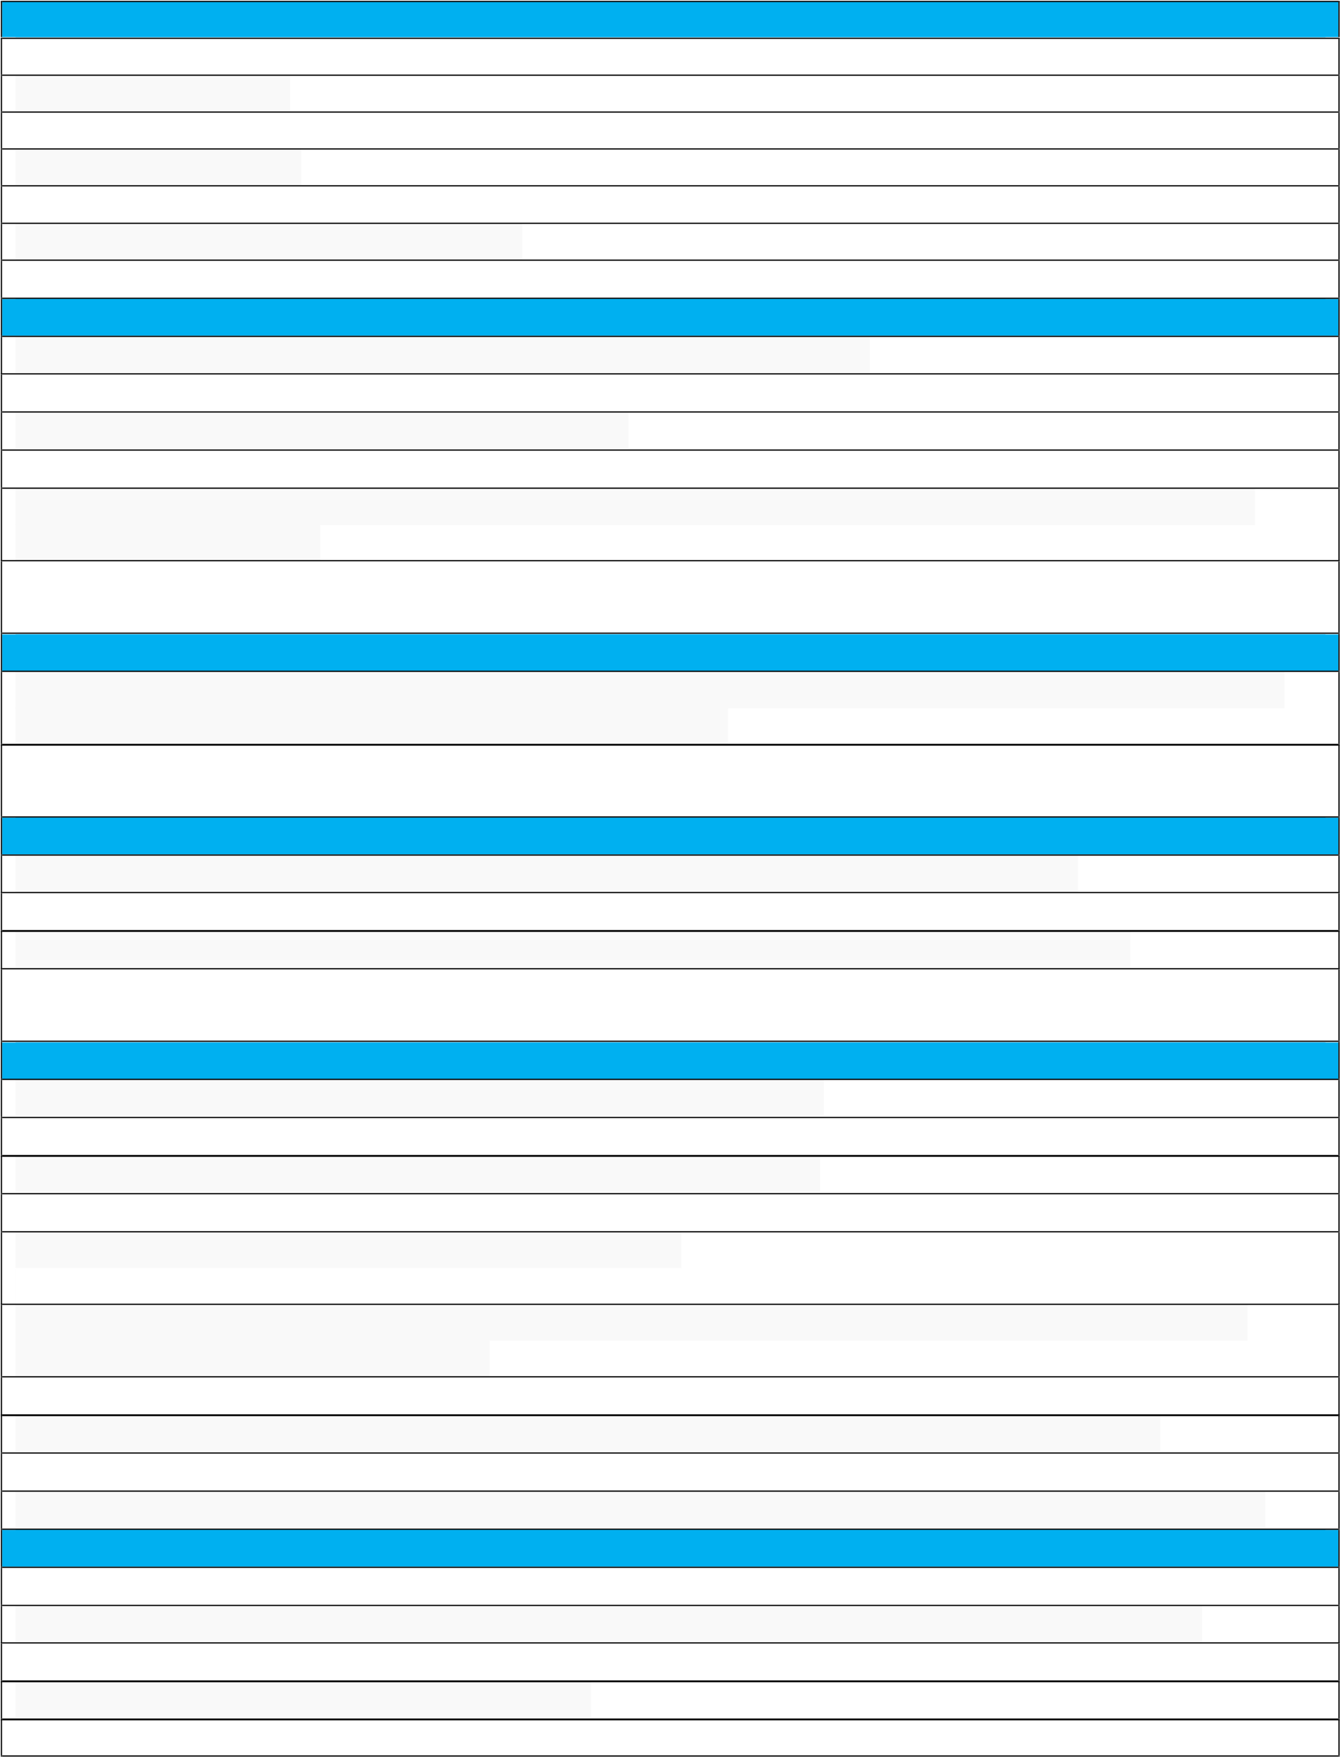**Measures** Compare, describe & solve practical problems for lengths & heights. Compare, describe & solve practical problems for weights & mass. Compare, describe & solve practical problems for capacity & volume Measure and begin to record units of mass and weight.

Measure and begin to record units of length and height.

Recognise and know the value of different denominations or coins & notes.

Sequence events in chronological order using language (e.g. before, after, next, first, today, yesterday, tomorrow, morning, afternoon, evening).

Recognise and use language relating to dates, including days of the week, weeks, months, years. Compare, describe & solve practical problems relating to time (verbally, practically or recorded) Measure and begin to record units of capacity and volume.

Tell the time to the hour and half past the hour and draw the hands on a clock face to show these times. **Geometry**

Recognise and name common 2D shapes, e.g. circles, triangles

Identify and describe common 2D shapes, including: rectangles (including squares) circles, triangles Describe position, direction and movement, including half, quarter and three-quarter turns Link position, direction and movement to shapes.

Recognise and name common 3D shapes, including: cuboids (including cubes), pyramids, spheres.

# Maths Objectives – Year 2

## Number & Place Value

Count in steps of 2 from 0, forwards & backwards from a given number

Count in steps of 3 from 0, forwards & backwards from a given number

Count in steps of 5 from 0, forwards & backwards from a given number

Count in steps of 10 from any number, forwards & backwardsRead and write numbers to at least 100 in numerals Read and write numbers to at least 100 in words.

Compare and order numbers from 0 up to 100; using < > and = signs.

Recognise the place value of each digit in a 2 digit number

Recognise odd and even numbers

## Addition & Subtraction

Recall and use addition facts to 20 fluently and derive and use related facts up to 100.

Recall and use subtraction facts to 20 fluently and derive and use related facts up to 100.

Add and subtract numbers mentally, including: 2-digit numbers and ones.

Add and subtract numbers mentally, including: 2-digit numbers and tens.

Add and subtract numbers mentally, including: two 2-digit numbers.

Add and subtract numbers mentally, including: adding three 1-digit numbers

Show that addition of any two numbers can be done in any order (commutative) and subtraction of one number from another cannot.

Recognise and use the inverse relationship between addition and subtraction and use this to check calculations.

Recognise and use the inverse relationship between addition and subtraction and use this to solve missing number problems.

## Multiplication & Division

Instantly recall and know multiplication and division facts for the 2 times table.

Instantly recall and know multiplication and division facts for the 5 times table.

Instantly recall and know multiplication and division facts for the 10 times table.

Calculate the mathematical statements for multiplication and division within the multiplication tables and write them using the x ÷ = signs.

Recognise that division is the inverse of multiplication and use to check calculations.

## Fractions

Recognise, find, name and write 1/3 of a length, shape, set of objects, or quantity.

Recognise, find, name and write 1/4, 2/4, 3/4 of a length, shape, set of objects, or quantity.

Recognise, find, name and write 1/2 of a length, shape, set of objects, or quantity.

Write simple fractions and recognise the equivalence.

**Statistics** Interpret and construct simple tables.

Interpret and construct pictograms.

Interpret and construct tally charts.

Interpret and construct block diagrams.

Ask and answer simple questions by counting the number of objects in each category and sorting the categories by quantity.

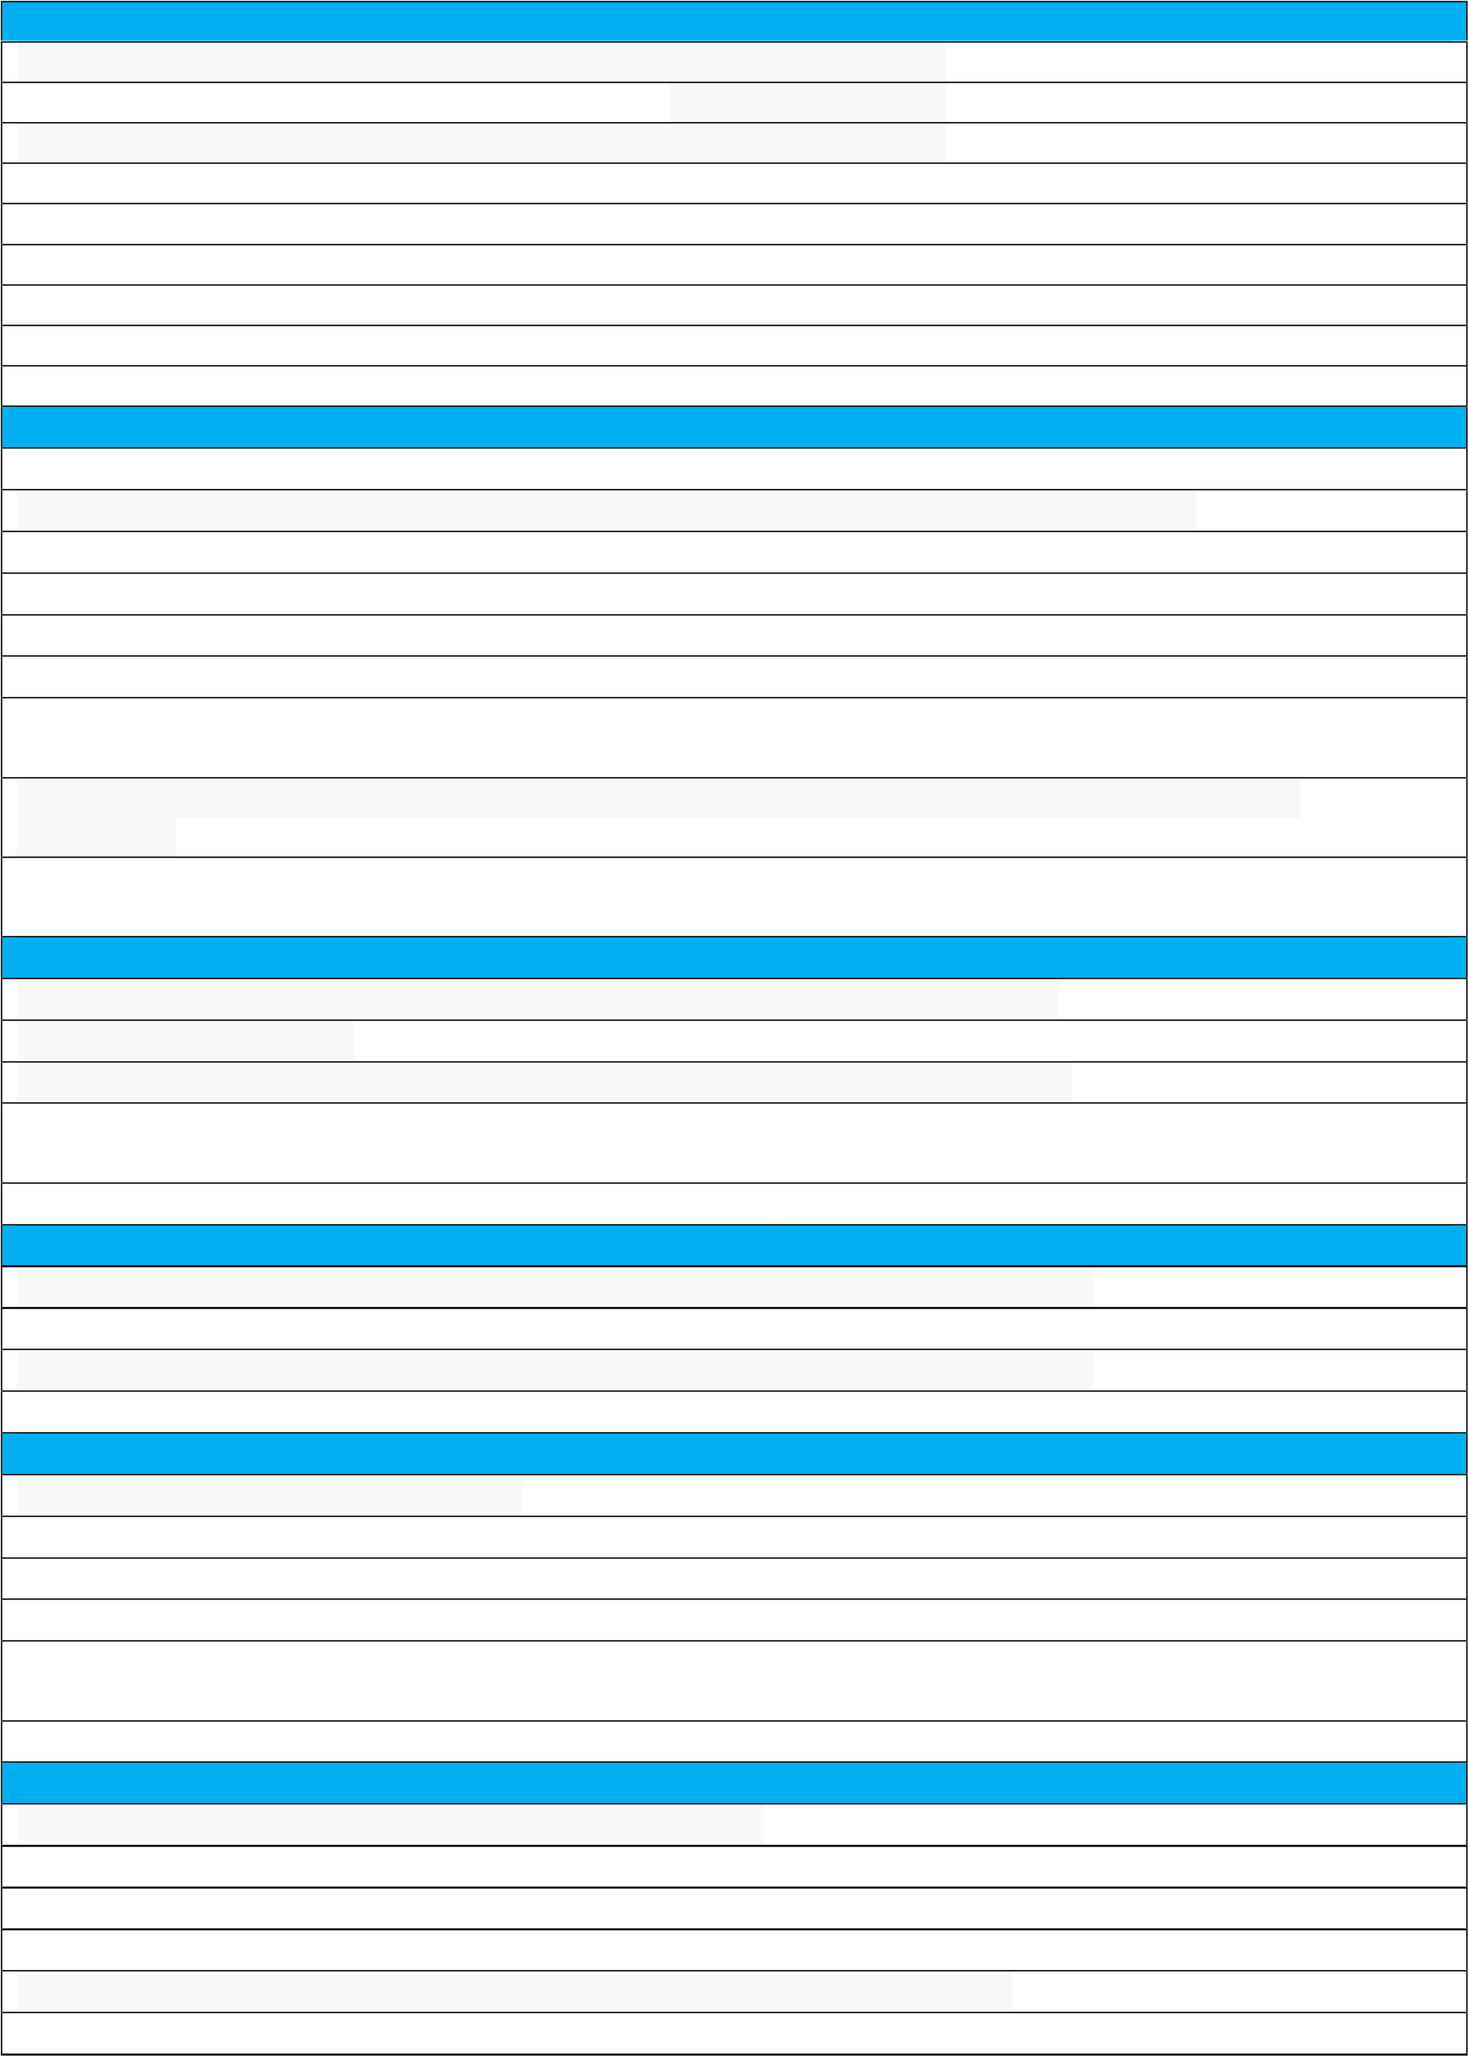Ask and answer questions about totalling and compare categorical data. **Measures** Compare and order length and mass, using < > = to record.

Compare and order capacity and volume, using < > = to record.

Recognise and use symbols for pounds (£) and pence (p).

Combine amounts (£/p) to make a particular value

Find different combinations of coins that equal the same amounts of money.

Tell and write the time to quarter past and draw the hands on a clock face to show this.

|  |  |  |  |  |  |  |  |  |
| --- | --- | --- | --- | --- | --- | --- | --- | --- |
| Tell and write the time to the hour and draw the hands on a clock face to show this. | | | | | | | | |
| Tell and write the time to five minutes, including quarter past/to the hour and draw the hands on a clock face to show these times. | | | | | | | | |
|  | Compare and sequence intervals of time. | | |  | | | | |
| Solve simple problems in a practical context involving addition and subtraction of money of the same unit, including giving change. | | | | | | | | |
| Use appropriate standard units to estimate and measure: length/height in any direction (m/cm); mass (kg/g) to the nearest appropriate unit, using rulers and scales. | | | | | | | | |
| Choose and use appropriate standard units to estimate and measure capacity (l/ml) to the nearest appropriate unit, using measuring vessels. | | | | | | | | |
|  | Choose and use appropriate standard units to estimate and measure: temperature (C); to the nearest | | | | |  | | |
| appropriate unit, using, thermometers. | |  | | |
| **Geometry** | | | | | | | | |
| Identify and describe the properties of 2-D shapes, including the number of sides and lines of symmetry | | | | | | | | |
|  | Identify and describe the properties of 3-D shapes, including the number of edges, vertices and faces. | | | | | |  | |
| Identify 2-D shapes on the surface of 3-D shapes, [for example, a circle on a cylinder and a triangle on a pyramid]. | | | | | | | | |
|  | Compare and sort common 2-D and 3-D shapes and everyday objects by their properties | | | |  | | | |
| Order and arrange combinations of mathematical objects in patterns and sequences. | | | | | | | | |
|  | Use mathematical vocabulary to describe position, direction and movement, including movement in a straight | | | | | | |  |
| line. |  | | | | | |
| Distinguish between rotation as a turn and in terms of right angles for quarter, half and three-quarter turns (clockwise and anticlockwise). | | | | | | | | |

# Maths Objectives – Year 3

**Number & Place Value** Count on from 0 in multiples of 4 and back.

Count from 0 in multiples of 8 and back.

Count from 0 in multiples of 50 and back.

Count from 0 in multiples of 100 and back.

Find 10 or 100 more or less than a given number.

Read and write numbers up to 1,000 in numerals.

Read and write numbers up to 1,000 in words.

Compare and order numbers up to 1,000 with a secure use of < > =.

Recognise the place value of each digit in up to 3-digit numbers.

## Addition & Subtraction

Add numbers mentally, including: 3-digit number and ones; 3-digit numbers and tens; 3-digit numbers and hundreds

Subtract numbers mentally, including: 3-digit number and ones; 3-digit numbers and tens; 3-digit numbers and hundreds

Use the formal method of columnar addition to add numbers with up to 3-digits.

Use the formal method of subtraction to subtract numbers with up to 3-digits.

Make reasonable estimations to the answer to a calculation.

Use the inverse operations to check answers.

Add measures of length, weight and volume with up to 3-digits, using formal methods.

Subtract measures of length, weight and volume with up to 3-digits, using formal methods.

Solve single step words problems that use addition.

Solve single step reasoning problems that use subtraction.

Solve more complex addition and subtraction reasoning problems (e.g. missing numbers, place value, number facts).

**Multiplication & Division** Instantly recall the 3 times table and relevant division facts.

Instantly recall the 4 times table and relevant division facts.

Instantly recall the 8 times table and relevant division facts.

Calculate 2-digit by 1-digit multiplication problems using mental and formal methods.

Calculate 2-digit by 1-digit division problems using mental and formal methods.

Calculate multiplication and division problems using measures (e.g. money, length).

Calculate single step reasoning problems using multiplication.

Calculate single step reasoning problems using division.

## Fractions

Recognise and show, using diagrams, equivalent fractions with small denominators (up to twelfths)

Recognise, find and write fractions of a discrete set of objects: unit fractions and non-unit fractions with small denominators.

Compare and order fractions with the same denominator.

Add fractions with the same denominator within one whole.

Subtract fractions with the same denominator within one whole.

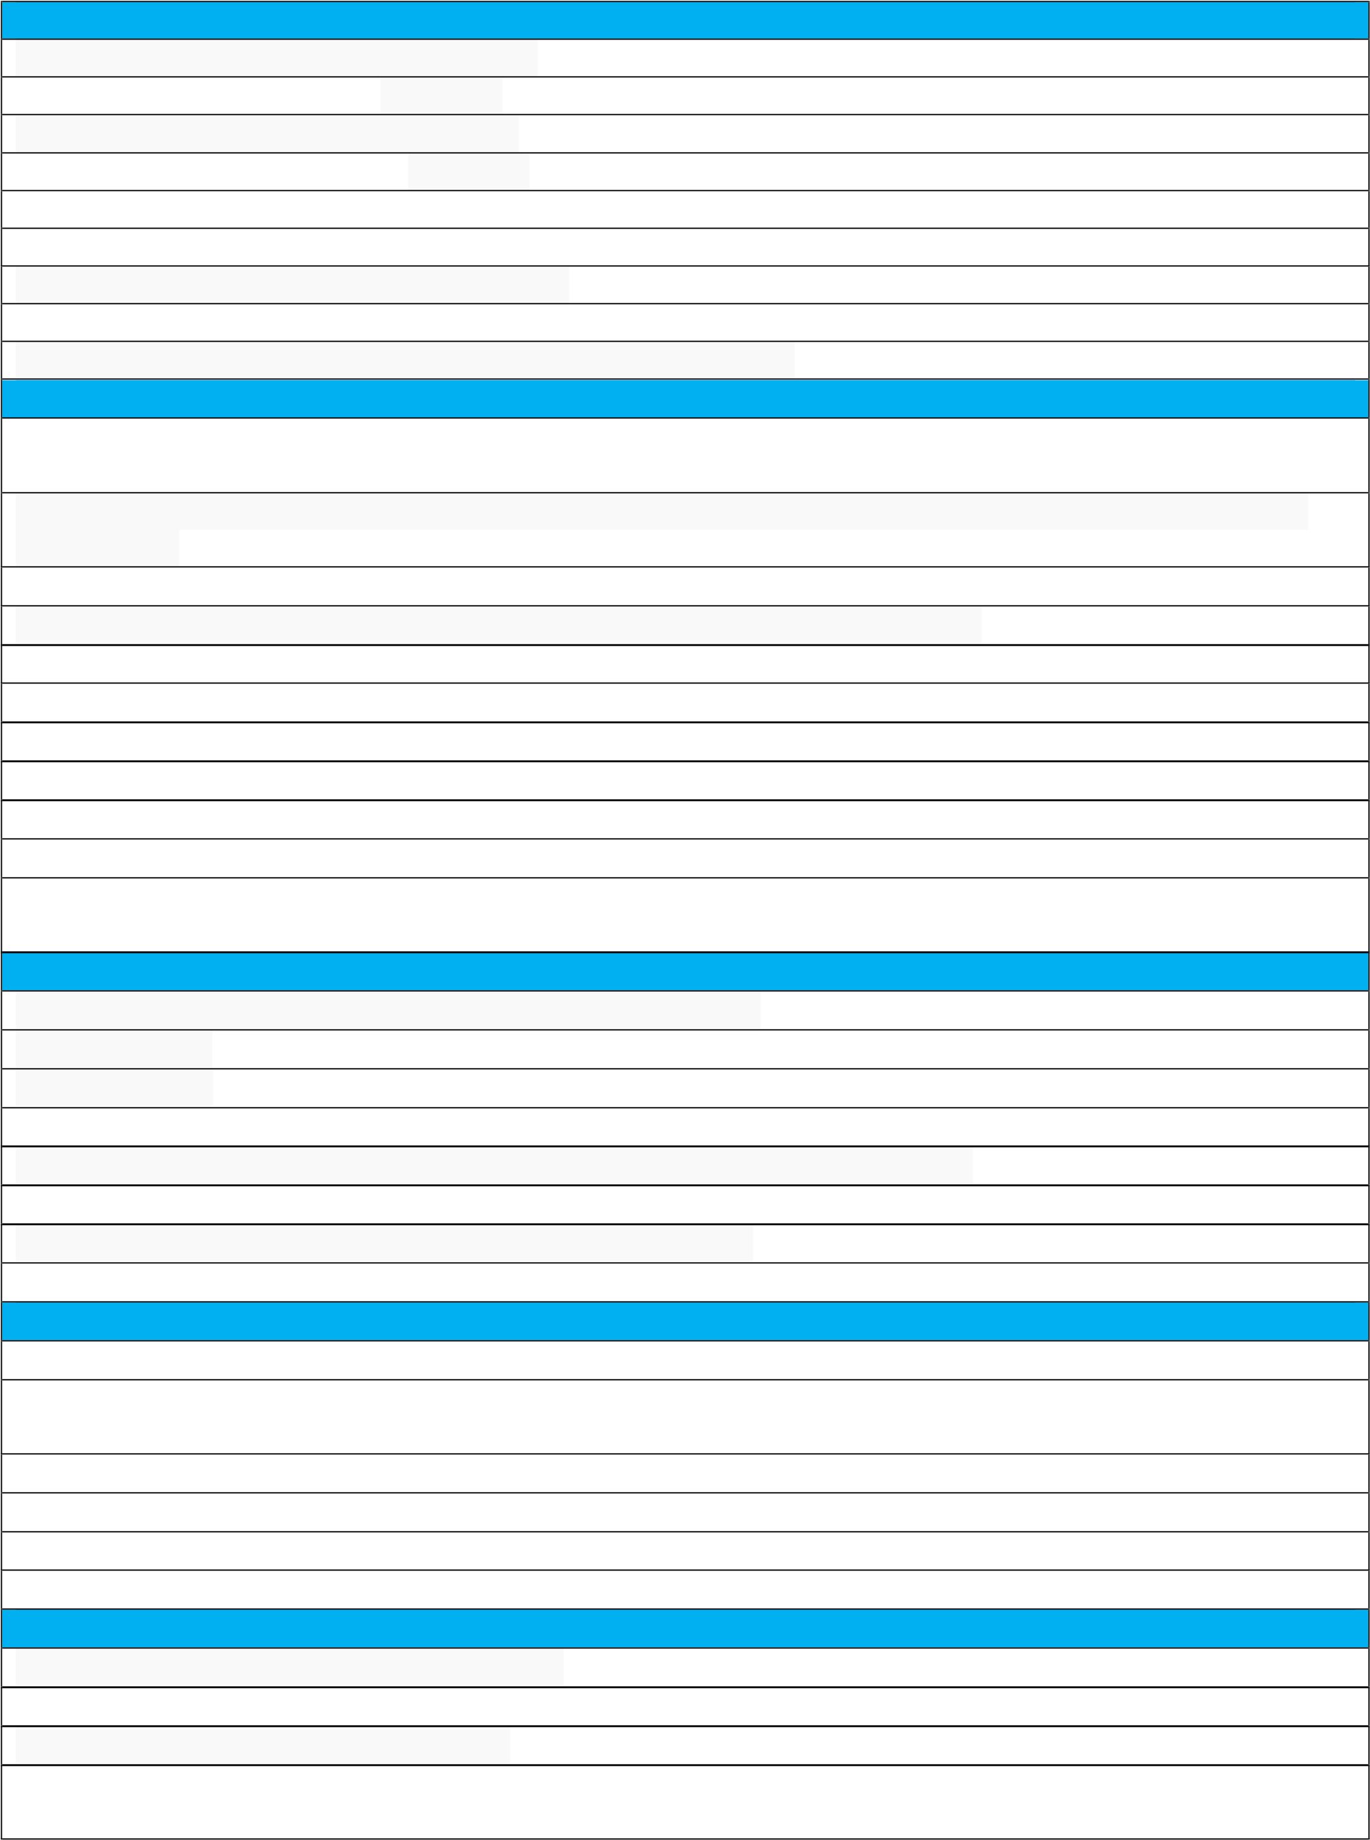Count up and down in tenths and recognise that tenth arise from splitting an object into ten equal parts. **Statistics** Interpret and present data using bar charts.

Interpret and present data using pictograms.

Interpret and present data using tables.

Solve 1-step and 2-step questions such as ‘How many more?’ and ‘How many fewer?’ using information presented in scaled bar charts pictograms and other graphs.

|  |  |  |  |  |  |  |
| --- | --- | --- | --- | --- | --- | --- |
| **Measures** | | | | | | |
| Measure the perimeter of simple 2D shapes accurately. | | | | | | |
| Measure and compare lengths (m/cm/mm). | | | | | | |
|  | Measure and compare mass (kg/g). |  | | | | |
| Measure and compare volume/capacity (l/ml). | | | | | | |
| Add measures of length, mass and volume/capacity. | | | | | | |
| Subtract measures of length, mass and volume/capacity. | | | | | | |
| Estimate and read time to the nearest minute. | | | | | | |
| Tell and write the time from an analogue clock to the minute. | | | | | | |
|  | Know and use (in time) Roman numerals from I to XII (context: clocks) | | |  | | |
| Accurately read 12-hour clocks. | | | | | | |
| Accurately read 24-hour clocks. | | | | | | |
| Record and compare time (seconds/minutes/hours). | | | | | | |
|  | Know and use vocabulary such as o'clock, am/pm, morning, afternoon, noon and midnight. | | | |  | |
|  | Know the number of days in each month and the order of the months. | |  | | | |
| Know the number of days in a year (including leap years). | | | | | | |
| Compare the duration of events (e.g. time taken by a journey or the number of days to an event). | | | | | | |
| **Geometry** | | | | | | |
| Make 3D shapes using physical resources and modelling materials. | | | | | | |
| Recognise and describe 3D shapes in different orientations. | | | | | | |
| Accurately draw 2D shapes. | | | | | | |
| Recognise angles as a property of shapes. | | | | | | |
| Identify and describe right angles. | | | | | | |
|  | Recognise that two right angles make a half-turn, three make a three quarter turn and four make a full turn. | | | | |  |
| Identify whether angles are greater or less than a right angle | | | | | | |
| Know the number of degrees in a quarter turn, half turn, three-quarter turn and full turn. | | | | | | |
| Identify (and know the meaning of) horizontal and vertical lines. | | | | | | |
| Identify (and know the meaning of) perpendicular lines. | | | | | | |
| Identify (and know the meaning of) parallel lines. | | | | | | |

# Year 4

|  |  |  |  |  |  |  |  |  |  |  |  |  |  |  |  |  |  |  |  |  |  |  |  |  |
| --- | --- | --- | --- | --- | --- | --- | --- | --- | --- | --- | --- | --- | --- | --- | --- | --- | --- | --- | --- | --- | --- | --- | --- | --- |
| **Number & Place Value** | | | | | | | | | | | | | | | | | | | | | | | | |
| Count backwards through zero to include negative numbers from any number. | | | | | | | | | | | | | | | | | | | | | | | | |
| Confidently count on and backwards in multiples of 6. | | | | | | | | | | | | | | | | | | | | | | | | |
|  | Confidently count on and backwards in multiples of 7. | | | | | | |  | | | | | | | | | | | | | | | | |
| Confidently count on and backwards in multiples of 9. | | | | | | | | | | | | | | | | | | | | | | | | |
|  | Confidently count on and backwards in multiples of 25. | | | | | | | |  | | | | | | | | | | | | | | | |
| Confidently count on and backwards in multiples of 25. | | | | | | | | | | | | | | | | | | | | | | | | |
|  | Read Roman numerals up to 100 (C). | | | | |  | | | | | | | | | | | | | | | | | | |
| Write Roman numerals up to 100 (C). | | | | | | | | | | | | | | | | | | | | | | | | |
|  | Recognise the place value of each digit in a four-digit number (1,000s, 100s, 10s, and 1s). | | | | | | | | | | | | | | | | | |  | | | | | |
| Find 1000 more or less than a given number. | | | | | | | | | | | | | | | | | | | | | | | | |
|  | Order & compare numbers beyond 1000, and confidently & independently use < > =. | | | | | | | | | | | | | | | | |  | | | | | | |
| Round any number to the nearest 10, 100 and 1000. | | | | | | | | | | | | | | | | | | | | | | | | |
| **Addition & Subtraction** | | | | | | | | | | | | | | | | | | | | | | | | |
|  | Add numbers with up to 4 digits using the formal written methods of columnar addition. | | | | | | | | | | | | | | | | | |  | | | | | |
| Subtract numbers with up to 4 digits using the formal written methods of subtraction. | | | | | | | | | | | | | | | | | | | | | | | | |
|  | Make reasonable estimations for answers, using the inverse to check their answer. | | | | | | | | | | | | | | | | |  | | | | | | |
| Solve complex 2-step reasoning problems using both addition, subtraction and a mixture of both (including different contexts). | | | | | | | | | | | | | | | | | | | | | | | | |
| **Multiplication & Division** | | | | | | | | | | | | | | | | | | | | | | | | |
|  | Instantly recall all multiplication facts up to 12 x 12 in any order. | | | | | | | | | | |  | | | | | | | | | | | | |
|  | Instantly recall | | all division facts up to 12 x 12 in any order. | | | | | | | | | | | | | | | | | | | | | |
| Recognise and use factor pairs and commutativity in mental calculations. | | | | | | | | | | | | | | | | | | | | | | | | |
| Multiply 2-digit by a 1-digit number using formal written method. | | | | | | | | | | | | | | | | | | | | | | | | |
|  | Multiply 3-digit numbers by a 1-digit number using formal written method. | | | | | | | | | | | | |  | | | | | | | | | | |
| Divide 2-digit numbers by a 1-digit number using formal written layout with no remainder. | | | | | | | | | | | | | | | | | | | | | | | | |
|  | Divide 3-digit numbers by a 1-digit number using formal written layout with no remainder. | | | | | | | | | | | | | | | | | | |  | | | | |
| Use place value, known and derived facts to multiply and divide mentally, including multiplying by 0 and 1. | | | | | | | | | | | | | | | | | | | | | | | | |
|  | Mentally multiply three numbers together. | | | | | |  | | | | | | | | | | | | | | | | | |
| Multiply a number with up to 2 decimal places by 10 and 100, and be able to explain what happens in regards to place value. | | | | | | | | | | | | | | | | | | | | | | | | |
|  | When multiplying by 10 or 100, identify the value of the digits in the answer as ones, tenths and hundredths. | | | | | | | | | | | | | | | | | | | | | | |  |
| **Fractions & Decimals** | | | | | | | | | | | | | | | | | | | | | | | | |
| Recognise and show, using diagrams, families of common equivalent fractions. | | | | | | | | | | | | | | | | | | | | | | | | |
|  | Count up and down in hundredths; recognise that hundredths arise when dividing an object by 100 and | | | | | | | | | | | | | | | | | | | | |  | | |
| dividing tenths by 10. | | | |  | | | | | | | | | | | | | | | | |
| Add fractions with the same denominator. | | | | | | | | | | | | | | | | | | | | | | | | |
| Subtract fractions with the same denominator. | | | | | | | | | | | | | | | | | | | | | | | | |
| Recognise and write decimal equivalents of any number of tenths or hundredths. | | | | | | | | | | | | | | | | | | | | | | | | |
|  | Recognise and write decimal equivalents to 1/4 , 1/2 and 3/4. | | | | | | | | |  | | | | | | | | | | | | | | |
| Round decimals with 1 decimal place to the nearest whole number. | | | | | | | | | | | | | | | | | | | | | | | | |
|  | Compare numbers with the same number of decimal places up to 2 decimal places. | | | | | | | | | | | | | | | |  | | | | | | | |
| Solve simple measure and money problems involving fractions and decimals to 2 decimal places. | | | | | | | | | | | | | | | | | | | | | | | | |
|  | Solve problems involving increasingly harder fractions to calculate quantities, and fractions to divide | | | | | | | | | | | | | | | | | | | |  | | | |
| quantities, including non-unit fractions where the answer is a whole number. | | | | | | | | | | | | | |  | | | | | |
| **Statistics** | | | | | | | | | | | | | | | | | | | | | | | | |
| Interpret, present & define discrete and continuous data using appropriate graphical methods, including bar charts and time graphs. | | | | | | | | | | | | | | | | | | | | | | | | |
|  | Solve comparison, sum and difference problems using information presented in bar charts, pictograms, table | | | | | | | | | | | | | | | | | | | | | | | s |
| and other graphs. | | |  | | | | | | | | | | | | | | | | | | | |
| **Measures** | | | | | | | | | | | | | | | | | | | | | | | | |
| Convert between different measurements (e.g hour to minute, km to m etc.).  Measure and calculate the perimeter of a rectilinear figure (including squares) in centimetres and metres. | | | | | | | | | | | | | | | | | | | | | | | | |
| Find the area of rectilinear shapes by counting squares. | | | | | | | | | | | | | | | | | | | | | | | | |
| Estimate, compare and calculate different measures, including money in pounds and pence. | | | | | | | | | | | | | | | | | | | | | | | | |
| Read, write and convert time between analogue and digital 12- and 24-hour clocks. | | | | | | | | | | | | | | | | | | | | | | | | |
|  | Solve problems involving converting from hours to minutes, minutes to seconds, years to months, weeks to | | | | | | | | | | | | | | | | | | | | | |  | |
| days. |  | | | | | | | | | | | | | | | | | | | | |
| **Geometry** | | | | | | | | | | | | | | | | | | | | | | | | |
| Compare and classify geometric shapes, including quadrilaterals and triangles, based on their properties and sizes. | | | | | | | | | | | | | | | | | | | | | | | | |
|  | Describe positions on a 2D grid as coordinates in the first quadrant. | | | | | | | | | | | |  | | | | | | | | | | | |
| Identify lines of symmetry in 2D shapes presented in different orientations. | | | | | | | | | | | | | | | | | | | | | | | | |
|  | Complete a simple symmetric figure with respect to a specific line of symmetry. | | | | | | | | | | | | | | |  | | | | | | | | |
| Describe movements between positions as translations of a given unit to the left/right and up/down. | | | | | | | | | | | | | | | | | | | | | | | | |
|  | Plot specified points and draw sides to complete a given polygon. | | | | | | | | | |  | | | | | | | | | | | | | |
| Identify acute and obtuse angles. | | | | | | | | | | | | | | | | | | | | | | | | |
| Compare and order angles. | | | | | | | | | | | | | | | | | | | | | | | | |

# Year 5

|  |  |  |  |  |  |  |  |  |  |  |  |  |  |  |  |  |  |  |  |  |  |  |  |
| --- | --- | --- | --- | --- | --- | --- | --- | --- | --- | --- | --- | --- | --- | --- | --- | --- | --- | --- | --- | --- | --- | --- | --- |
| **Number & Place Value** | | | | | | | | | | | | | | | | | | | | | | | |
| Count forward or backwards in steps of powers of 10 for any given number up to 1,000,000. | | | | | | | | | | | | | | | | | | | | | | | |
|  | Interpret negative numbers in context. |  | | | | | | | | | | | | | | | | | | | | | |
|  | Count forward and backwards with positive and negative numbers including through zero. | | | | | | | | | | | | | |  | | | | | | | | |
| Read and write Roman numerals to 1000 (M) and recognise years written in Roman numerals. | | | | | | | | | | | | | | | | | | | | | | | |
| Read, write, order and compare numbers to at least 1,000,000. | | | | | | | | | | | | | | | | | | | | | | | |
| Determine the value of each digit up to 1,000,000 in words and numerals. | | | | | | | | | | | | | | | | | | | | | | | |
|  | Round any number up to 1,000,000 to the nearest 10, 100, 1000, 10000 or 100000. | | | | | | | | | | |  | | | | | | | | | | | |
| Confidently solve complex or multi-step reasoning problems involving knowledge of the number system and place value. | | | | | | | | | | | | | | | | | | | | | | | |
|  | Understand that the equals sign shows an equilibrium between both sides of an equation | | | | | | | | | | | | |  | | | | | | | | | |
| **Addition & Subtraction** | | | | | | | | | | | | | | | | | | | | | | | |
| Add numbers with more than 4-digits using formal written methods. | | | | | | | | | | | | | | | | | | | | | | | |
| Subtract numbers with more than 4-digits using formal written methods. | | | | | | | | | | | | | | | | | | | | | | | |
| Add increasingly large numbers mentally. | | | | | | | | | | | | | | | | | | | | | | | |
| Subtract increasingly large numbers mentally. | | | | | | | | | | | | | | | | | | | | | | | |
| Use rounding to check answers to calculations and determine accuracy in the context of a problem. | | | | | | | | | | | | | | | | | | | | | | | |
| Solve addition and subtraction multi-step/reasoning problems in contexts, deciding which operations and methods to use and be able to explain why. | | | | | | | | | | | | | | | | | | | | | | | |
| **Multiplication & Division** | | | | | | | | | | | | | | | | | | | | | | | |
| Identify multiples and common multiples of any given number. | | | | | | | | | | | | | | | | | | | | | | | |
| Identify factor pairs of a number. | | | | | | | | | | | | | | | | | | | | | | | |
| Identify common factors of two numbers. | | | | | | | | | | | | | | | | | | | | | | | |
| Know and use the vocabulary of prime numbers, prime factors and composite (non-prime) numbers. | | | | | | | | | | | | | | | | | | | | | | | |
| Be able to establish whether a number up to 100 is prime. | | | | | | | | | | | | | | | | | | | | | | | |
|  | Recall prime numbers up to 19 by heart. |  | | | | | | | | | | | | | | | | | | | | | |
| Multiply numbers up to 4 digits by a 1-digit number using a formal written method. | | | | | | | | | | | | | | | | | | | | | | | |
| Multiply numbers up to 4 digits by a 2-digit number using a formal written method (long multiplication). | | | | | | | | | | | | | | | | | | | | | | | |
| Multiply numbers mentally, drawing upon known facts. | | | | | | | | | | | | | | | | | | | | | | | |
| Divide numbers mentally, drawing upon known facts. | | | | | | | | | | | | | | | | | | | | | | | |
| Divide numbers up to 4 digits by a one-digit number using the formal written method of short division and interpret remainders appropriately for the context (e.g. decimals, money etc | | | | | | | | | | | | | | | | | | | | | | | |
|  | Multiply and divide whole numbers by 10, 100 and 1000. | | | | | | |  | | | | | | | | | | | | | | | |
| Multiply and divide decimal numbers by 10, 100 and 1000. | | | | | | | | | | | | | | | | | | | | | | | |
|  | Recognise and use square numbers and cube numbers, and the notation for squared (²) and cubed (³). | | | | | | | | | | | | | | | | | | |  | | | |
| Solve complex reasoning problems involving multiplication and division, including using their knowledge of factors and multiples, squares and cubes. | | | | | | | | | | | | | | | | | | | | | | | |
|  | Solve complex reasoning problems involving addition, subtraction, multiplication and division and a combination | | | | | | | | | | | | | | | | | | | | | |  |
| of these, including understanding the meaning of the equals sign. | | | | | | | |  | | | | | | | | | | | | | |
| Solve complex reasoning problems involving multiplication and division, including scaling by simple fractions and problems involving simple rates. | | | | | | | | | | | | | | | | | | | | | | | |
| **Fractions, Decimals & Percentages** | | | | | | | | | | | | | | | | | | | | | | | |
|  | Count up and down in thousandths; recognise that thousandths arise from dividing an object into 1000 equal | | | | | | | | | | | | | | | | | | | | |  | |
| parts and in dividing numbers or quantities by 1000. | | | | | |  | | | | | | | | | | | | | | |
| Identify, name and write equivalent fractions of a given fraction, represented visually, including tenths and hundredths. | | | | | | | | | | | | | | | | | | | | | | | |
|  | Read and write decimal numbers and percentages as fractions, e.g. 0.71 = 71/100/ 71% - 0.71). | | | | | | | | | | | | | | | | |  | | | | | |
| Recognise mixed numbers and improper fractions and convert from one form to the other. | | | | | | | | | | | | | | | | | | | | | | | |
|  | Compare and order fractions whose denominators are all multiples of the same number. | | | | | | | | | | | |  | | | | | | | | | | |
| Round decimals with two decimal places to the nearest whole number and to one decimal place. | | | | | | | | | | | | | | | | | | | | | | | |
|  | Read, write, order and compare numbers with up to three decimal places. | | | | | | | | |  | | | | | | | | | | | | | |
| Recognise the percent symbol (%) and understand that per cent means 'of/out of 100'. | | | | | | | | | | | | | | | | | | | | | | | |
|  | Add a range of fractions with the same denominator and multiples of the same denominator. | | | | | | | | | | | | | | | |  | | | | | | |
| Subtract a range of fractions with the same denominator and multiples of the same denominator. | | | | | | | | | | | | | | | | | | | | | | | |
|  | Multiply proper fractions by whole numbers. | | |  | | | | | | | | | | | | | | | | | | | |
| Multiply mixed numbers by whole numbers. | | | | | | | | | | | | | | | | | | | | | | | |
|  | Multiply improper fractions by whole numbers. | | | |  | | | | | | | | | | | | | | | | | | |
| Know the decimal, fractional and percentage equivalents of 1/2, 1/4, 1/5, 2/5 and 4/5. | | | | | | | | | | | | | | | | | | | | | | | |
|  | Solve complex reasoning problems that require knowledge of fractions. decimals and percentages. | | | | | | | | | | | | | | | | | |  | | | | |
| **Statistics** | | | | | | | | | | | | | | | | | | | | | | | |
| Complete, read and interpret information in: various tables, including timetables (e.g. buses). | | | | | | | | | | | | | | | | | | | | | | | |
|  | Solve comparison, sum and difference problems using information presented in a line graph. | | | | | | | | | | | | | | |  | | | | | | | |
| **Measures** | | | | | | | | | | | | | | | | | | | | | | | |
| Measure and calculate the perimeter of composite rectilinear shapes in cm and m. | | | | | | | | | | | | | | | | | | | | | | | |
|  | Calculate & compare the area of rectangles (including squares, & including using standard units, square | | | | | | | | | | | | | | | | | | | |  | | |
| centimetres (cm2) and square metres (m2). | |  | | | | | | | | | | | | | | | | | |
| Make accurate estimations for the area of irregular shapes. | | | | | | | | | | | | | | | | | | | | | | | |
| Estimate volume [for example, using 1 cm³ blocks to build cuboids (including cubes) and capacity [for example, using water]. | | | | | | | | | | | | | | | | | | | | | | | |
| Convert between different units of metric measure (e.g. km/m; cm/m; cm/mm; g/kg; l/ml). | | | | | | | | | | | | | | | | | | | | | | | |
| Solve problems involving converting between units of time (12/24, hours/minutes/days etc). | | | | | | | | | | | | | | | | | | | | | | | |
| Understand and use approximate equivalences between metric units and common imperial units such as inches, pounds, pints, and miles. | | | | | | | | | | | | | | | | | | | | | | | |
|  | Use all four operations to solve complex reasoning problems involving measures. | | | | | | | | | |  | | | | | | | | | | | | |
| **Geometry** | | | | | | | | | | | | | | | | | | | | | | | |
| Know that angles are measured in degrees. | | | | | | | | | | | | | | | | | | | | | | | |
|  | Estimate & compare acute, obtuse & reflex angles. | | | | |  | | | | | | | | | | | | | | | | | |
| Draw given angles and measure them in degrees. | | | | | | | | | | | | | | | | | | | | | | | |
| Identify angles around a point/at a full turn (360). | | | | | | | | | | | | | | | | | | | | | | | |
| Identify angles on a straight line/at a half-turn (180). | | | | | | | | | | | | | | | | | | | | | | | |
| Identify angles in other multiples of 90 (270 etc). | | | | | | | | | | | | | | | | | | | | | | | |
| Identify, describe and represent the position of a shape following a reflection, using the appropriate language and know that the shape has not changed. | | | | | | | | | | | | | | | | | | | | | | | |
| Identify, describe and represent the position of a shape following a translation, using the appropriate language and know that the shape has not changed. | | | | | | | | | | | | | | | | | | | | | | | |
| Distinguish between regular and irregular polygons based on reasoning about equal sides and angles. | | | | | | | | | | | | | | | | | | | | | | | |
| Identify 3D shapes, including cubes and other cuboids, from 2D representations. | | | | | | | | | | | | | | | | | | | | | | | |
| Use the properties of rectangles to deduce related facts & find missing lengths & angles. | | | | | | | | | | | | | | | | | | | | | | | |

# Year 6

|  |  |  |  |  |  |  |  |  |  |  |  |  |  |  |  |  |  |  |  |  |  |  |  |  |
| --- | --- | --- | --- | --- | --- | --- | --- | --- | --- | --- | --- | --- | --- | --- | --- | --- | --- | --- | --- | --- | --- | --- | --- | --- |
| **Number & Place Value** | | | | | | | | | | | | | | | | | | | | | | | | |
| Read, write, order and compare numbers up to 10,000,000. | | | | | | | | | | | | | | | | | | | | | | | | |
| Determine the value of each digit up to 10,000,000. | | | | | | | | | | | | | | | | | | | | | | | | |
|  | Round any whole number to a required degree of accuracy. | | | | | | | | | |  | | | | | | | | | | | | | |
| Use negative numbers in context, and calculate intervals across 0. | | | | | | | | | | | | | | | | | | | | | | | | |
|  | Solve complex reasoning problems that require a secure knowledge of the number system and place value. | | | | | | | | | | | | | | | | | | |  | | | | |
| **Four Operations** | | | | | | | | | | | | | | | | | | | | | | | | |
| Perform mental calculations, including with mixed operations and large numbers. | | | | | | | | | | | | | | | | | | | | | | | | |
|  | Use knowledge of the order of operations to carry our calculations involving the four operations (BIDMAS). | | | | | | | | | | | | | | | | | | | | |  | | |
| Use estimation to check answers to calculations and determine, in the context of a problem, levels of accuracy. | | | | | | | | | | | | | | | | | | | | | | | | |
| **Addition & Subtraction** | | | | | | | | | | | | | | | | | | | | | | | | |
|  | Solve complex addition & subtraction multi-step reasoning problems in contexts, deciding which operations & | | | | | | | | | | | | | | | | | | | | | |  | |
| methods to use & why. | | |  | | | | | | | | | | | | | | | | | | |
| Add numbers up to 1,000,000 using the formal written method. | | | | | | | | | | | | | | | | | | | | | | | | |
|  | Subtract numbers up to 1,000,000 using the formal written method. | | | | | | | | | | | | |  | | | | | | | | | | |
| Add decimal numbers up to 3DP using the formal written method. | | | | | | | | | | | | | | | | | | | | | | | | |
|  | Subtract decimal numbers up to 3DP using the formal written method. | | | | | | | | | | | | | |  | | | | | | | | | |
| **Multiplication & Division** | | | | | | | | | | | | | | | | | | | | | | | | |
| Identify common factors, common multiples and prime numbers. | | | | | | | | | | | | | | | | | | | | | | | | |
| Multiply multi-digit numbers up to 4-digits by 2-digits using the formal written method of long multiplication. | | | | | | | | | | | | | | | | | | | | | | | | |
| Divide numbers up to 4-digits by a 2-digit whole number using the formal method of long division. | | | | | | | | | | | | | | | | | | | | | | | | |
| Divide numbers up to 4-digits by a 2-digit number using the formal written method of short division. | | | | | | | | | | | | | | | | | | | | | | | | |
| In formal division, interpret remainders as whole number remainders, fractions, or by rounding, as appropriate for the context. | | | | | | | | | | | | | | | | | | | | | | | | |
|  | Solve complex multiplication & division multi-step reasoning problems in contexts, deciding which operations & | | | | | | | | | | | | | | | | | | | | | | |  |
| methods to use & why. | | |  | | | | | | | | | | | | | | | | | | | |
| Multiply one-digit numbers with up to 2 decimal places by whole numbers. | | | | | | | | | | | | | | | | | | | | | | | | |
| **Fractions, Decimals & Percentages** | | | | | | | | | | | | | | | | | | | | | | | | |
|  | Use common factors to simplify fractions. | | | | | | | |  | | | | | | | | | | | | | | | |
| Use common multiples to express fractions in the same denomination. | | | | | | | | | | | | | | | | | | | | | | | | |
| Compare and order fractions, including fractions >1. | | | | | | | | | | | | | | | | | | | | | | | | |
| Add fractions with different denominators and mixed numbers, using the concept of equivalent fractions. | | | | | | | | | | | | | | | | | | | | | | | | |
|  | Subtract fractions with different denominators and mixed numbers, using the concept of equivalent | | | | | | | | | | | | | | | | | |  | | | | | |
| fractions. | |  | | | | | | | | | | | | | | | |
| Multiply simple pairs of proper fractions, writing the answer in its simplest form [for example, 1/4 × 1/2 = 1/8 ]. | | | | | | | | | | | | | | | | | | | | | | | | |
|  | Divide proper fractions by whole numbers [for example, 1/3 ÷ 2 = 1/6 ]. | | | | | | | | | | | | | | |  | | | | | | | | |
| Recall and use equivalences between simple fractions, decimals and percentages, including different contexts and through operations. | | | | | | | | | | | | | | | | | | | | | | | | |
|  | Multiply and divide numbers by 10, 100 and 1,000 giving answers up to 3 decimal places. | | | | | | | | | | | | | | | | |  | | | | | | |
| Solve problems that involve a mixture of operations with fractions, decimals and percentages requiring a secure knowledge of conversion. | | | | | | | | | | | | | | | | | | | | | | | | |
|  | Find percentages (multiples of 5) of amounts (e.g 15% of 660). | | | | | | | | | | |  | | | | | | | | | | | | |
| Find complex percentages of amounts (e.g 97% of 500). | | | | | | | | | | | | | | | | | | | | | | | | |
| **Ratio & Proportion** | | | | | | | | | | | | | | | | | | | | | | | | |
|  | Solve problems involving the relative sizes of 2 quantities where missing values can be found by using integer | | | | | | | | | | | | | | | | | | | | | |  | |
| multiplication and division facts. | | | | | | |  | | | | | | | | | | | | | | |
| Use percentages to compare proportional amounts. | | | | | | | | | | | | | | | | | | | | | | | | |
| Solve problems involving similar shapes where the scale factor is known or can be found. | | | | | | | | | | | | | | | | | | | | | | | | |
| Solve problems involving unequal sharing and grouping using knowledge of fractions and multiples. | | | | | | | | | | | | | | | | | | | | | | | | |
| Calculate an amount from a given ratio. | | | | | | | | | | | | | | | | | | | | | | | | |
| **Algebra** | | | | | | | | | | | | | | | | | | | | | | | | |
| Use simple formulae. | | | | | | | | | | | | | | | | | | | | | | | | |
| Generate and describe linear number sequences. | | | | | | | | | | | | | | | | | | | | | | | | |
| Express missing number problems algebraically | | | | | | | | | | | | | | | | | | | | | | | | |
|  | Find pairs of numbers that satisfy an equation with 2 unknowns. | | | | | | | | | | | |  | | | | | | | | | | | |
| Enumerate possibilities of combinations of 2 variables. | | | | | | | | | | | | | | | | | | | | | | | | |
| **Statistics** | | | | | | | | | | | | | | | | | | | | | | | | |
| Interpret, analyse and compare pie charts. | | | | | | | | | | | | | | | | | | | | | | | | |
| Interpret, analyse and compare line graphs. | | | | | | | | | | | | | | | | | | | | | | | | |
|  | Construct basic pie charts. | | | | |  | | | | | | | | | | | | | | | | | | |
| Construct basic line graphs. | | | | | | | | | | | | | | | | | | | | | | | | |
| **Measures** | | | | | | | | | | | | | | | | | | | | | | | | |
| Solve problems involving the calculation and conversion of units of measure, using decimal notation up to 3 decimal places where appropriate. | | | | | | | | | | | | | | | | | | | | | | | | |
|  | Use, read, write and convert between standard units, converting measurements of length, mass, volume and | | | | | | | | | | | | | | | | | | | |  | | | |
| time from a smaller unit of measure to a larger unit, and vice versa, using decimal notation to up to 3 decimal | | | | | | | | | | | | | | | | | | | | | |  | |
| places. |  | | | | | | | | | | | | | | | | | | | | |
| Convert between miles & km. | | | | | | | | | | | | | | | | | | | | | | | | |
|  | Calculate, estimate and compare volume of cubes and cuboids using standard units, including cm3 and m3, and | | | | | | | | | | | | | | | | | | | | | |  | |
| extending to other units such as mm3 and km3. | | | | | | | | |  | | | | | | | | | | | | |
| Recognise that shapes with the same areas can have different perimeters and vice versa. | | | | | | | | | | | | | | | | | | | | | | | | |
| Calculate the area of parallelograms. | | | | | | | | | | | | | | | | | | | | | | | | |
|  | Calculate the area of triangles. | | | | | |  | | | | | | | | | | | | | | | | | |
| **Geometry** | | | | | | | | | | | | | | | | | | | | | | | | |
| Draw 2-D shapes using given dimensions and angles. | | | | | | | | | | | | | | | | | | | | | | | | |
|  | Compare and classify geometric shapes based on their properties and sizes. | | | | | | | | | | | | | | | |  | | | | | | | |
| Find unknown angles in any triangles, quadrilaterals, and regular polygons. | | | | | | | | | | | | | | | | | | | | | | | | |
| Describe positions on the full coordinate grid. | | | | | | | | | | | | | | | | | | | | | | | | |
| Find missing co-ordinates across all four quadrants. | | | | | | | | | | | | | | | | | | | | | | | | |
| Draw and translate simple shapes on the coordinate plane and reflect them in the axes. | | | | | | | | | | | | | | | | | | | | | | | | |
| Recognise, describe and build simple 3D shapes, including making nets. | | | | | | | | | | | | | | | | | | | | | | | | |
| Illustrate and name parts of circles, including radius, diameter and circumference and know that the diameter is twice the radius. | | | | | | | | | | | | | | | | | | | | | | | | |
| Recognise angles where they meet at a point, are on a straight line, or are vertically opposite. | | | | | | | | | | | | | | | | | | | | | | | | |
|  | Calculate missing angles. | | | |  | | | | | | | | | | | | | | | | | | | |